Visoka škola strukovnih studija za

Informacione i komunikacione

Tehnologije

Berix

<http://berix.epizy.com/index.php>

Smer: Internet Tehnologije

Modul: Web Programiranje

Predmet: Web Programiranje PHP 1

**Berisavac Aleksa 32/18**

Contents

1. Uvod 4

1.1 Korišćene tehnologije 4

1.2 Opis Funkcionalnosti 4

1.3 Template 5

1.4 NAPOMENA 5

2. Objašnjenja O Izradi 6

2.1 Mapa Sajta 6

2.1.1 Robots: 6

2.2 #Nav 8

2.3 index.php 9

2.4 shop.php 12

2.5 author.php 15

2.6 #Contact 15

2.7 Anketa 16

2.8 Logovanje 18

2.9 Organizacija Baze Podataka 20

2.10 Organizacija fajlova 22

2.11 admin.php 23

3. Kodovi 23

3.1. HTML/PHP: 23

3.1.1 index.php: 23

3.2 main 24

3.2.1 404.php 24

3.2.2 admin.php 25

3.2.3 authorContent.php 27

3.2.4 checkout.php 28

3.2.5 indexContent.php 29

3.2.6 insertItemIntoTable.php 31

3.2.7 logout.php 32

3.2.8 shopContent.php 32

3.3 fixed 41

3.3.1 carousel.php 41

3.3.2 footer.php 42

3.3.3 head.php 44

3.3.4 navigation.php 45

3.3.5 scripts.php 47

3.3.6 survey.php 47

3.3.7 surveyShow.php 47

3.4 fixed/registration 50

3.4.1 login.php 50

3.4.1 recoverPassword.php 51

3.4.1 register.php 52

3.5 database 54

3.5.1 connection.php 54

3.5.2 credentials.php 54

3.6 database/communication 55

3.6.1 changePassword.php 55

3.6.2 deleteIdFromTable.php 58

3.6.3 getProducts.php 59

3.6.4 getProductsForCart.php 66

3.6.5 insertMessage.php 68

3.6.6 insertSurveyAnswers.php 71

3.6.7 registerUser.php 74

3.6.8 selectAllFromTable.php 79

3.6.9 selectMessages.php 81

3.6.10 selectSpecificItemInformation.php 81

3.6.11 userLogin.php 85

3.6.12 userLogout.php 88

?> 88

3.7 SCSS (pregledniji od css-a): 88

3.8 Javascript: 128

3.8.1 main.js: 128

# 1. Uvod

## 1.1 Korišćene tehnologije

* HTML 5
* CSS 3
* JavaScript
* Visual Studio Code
* jQuery
* Bootstrap
* Ajax
* Php
* SQL
* Photoshop

## 1.2 Opis Funkcionalnosti

* Dinamičko učitavanje nav menija javascriptom iz baze podataka, ajaksom.
* Bootstrap carousel
* Ceo sajt u potpunosti responzivan do max 1920px rezolucije. Vise od toga neprovereno.
* Dinamičko učitavanje sličnih blokova iz baze podataka. Ovo spodrazumeva proizvode, slike u galeriji, elemente futer i nav liste.
* Provera polja forme za kontakt korišćenjem regExpova i tajmera za uklanjanje obaveštenja nakon 5-10s. Isprogramirano dugme za prosleđivanje podataka sa alertom.
* Filter, sort i pretraga proizvoda na shop.html, kao i paginacija. Sve uskladjeno.
* Korpa za kupovinu na shop.html, odradjena javaskriptom i css-om. Podatke skladisti unutar local storage-a. Sve je dinamicki u potpunosti i komunicira se sa bazom..
* Sve je vecinom skladisteno u bazi podataka.
* U zavisnosti od toga da li je ulogovan obican ili admin korisnik razlikuje se prikaz nava.
* Omoguceno je logovanje, registracija, i oporavak passworda.
* Odradjeno anketiranje za uzimanje glasova, dinamicki se ispisuju odgovori i pitanja iz baze podataka i odgovori se cuvaju u bazi.
* Odradjen select i delete admin panela. Edit/insert za sada nije odradjen. Select optimizovan da pokaze bitne informacije u prirodnom obliku.

## 1.3 Template

* Korisceni su asseti sa prethodnog sajta. Vecina sadrzaja sto se tice slika i informacija za proizvode za mysql bazu preuzeta sa [asos.com](http://www.asos.com) dok je ostalo pravljeno photoshopom. Vecina pravljena od nule, samo shop main deo preuzet, sa izmenama (paginacija).

## 1.4 NAPOMENA

Kodovi nisu u potpunosti uskladjeni sa realnim stanjem na sajtu zbog cestog azuriranja, i unapredjivanja sajta.

# Objašnjenja O Izradi

## Mapa Sajta

<urlset xmlns="http://www.sitemaps.org/schemas/sitemap/0.9">

<url>

<loc>http://berix.epizy.com/index.php</loc>

<lastmod>2022-12-3</lastmod>

<changefreq>yearly</changefreq>

<priority>0.1</priority>

</url>

<url>

<loc>http://berix.epizy.com/pages/main/indexContent.php</loc>

<lastmod>2022-12-3</lastmod>

<changefreq>monthly</changefreq>

<priority>0.5</priority>

</url>

<url>

<loc>http://berix.epizy.com/pages/main/shopContent.php</loc>

<lastmod>2022-12-3</lastmod>

<changefreq>weekly</changefreq>

<priority>1.0</priority>

</url>

<url>

<loc>http://berix.epizy.com/pages/main/authorContent.php</loc>

<lastmod>2022-12-3</lastmod>

<changefreq>monthly</changefreq>

<priority>0.3</priority>

</url>

</url>

<url>

<loc>http://berix.epizy.com/pages/main/admin.php</loc>

<lastmod>2022-12-3</lastmod>

<changefreq>monthly</changefreq>

<priority>0.3</priority>

</url>

</urlset>

### Robots:

User-agent: *

Disallow:

## 2.2 #Nav

Navigacija sajta je napravljena tako da se elementi dinamički ispišu iz baze podataka, ajaksom. Responzivna je i kada se rezolucija dovoljno smanji pojavljuje se hamburger iza kojeg stoji meni. Funkcionalnost ovog menija odradjena je pomocu javascripta i php-a. Na klik na meni on se pojavi i kada se nesto izabere on nestane. U zavisnosti od toga da li je korisnik ulogovan, i da li je admin, blago ce se razlikovati postojanje meni item-a.



Ispod se može videti padajući meni iz hamburgera koji se otvara na pritisak preko mobilnog, ili na hover ako je sa mišem.

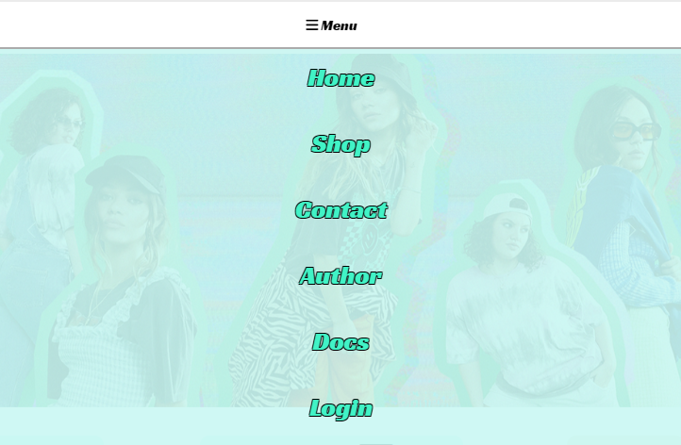

## 2.3 index.php

Ovde, kao i u ostalim stranicama sajta, prvo se nailazi na header koji u sebi sadrzi carousel koji je interaktivan. Ovo je preuzeto iz bootstrapa, sa tim sto se elementi dinamicki ispisuju iz baze podataka sa kojom se komunicira preko ajaxa. Dobar deo responzivnosti dolazi preko @media u css-u. Ispod header-a, u mainu, nalazi se kratak intro samog sajta I hyperlink za preusmeravanje na samu prodavnicu. Anketi se pristupa preko dugmeta koje se prilagodjava u zavisnosti od statusa ulogovanosti korisnika. Bice posebne reci o njemu u delu za #survey .Footer je ovde zajednicki kao I u svim ostalim stranicama. Vise o njemu u delu za #contact.

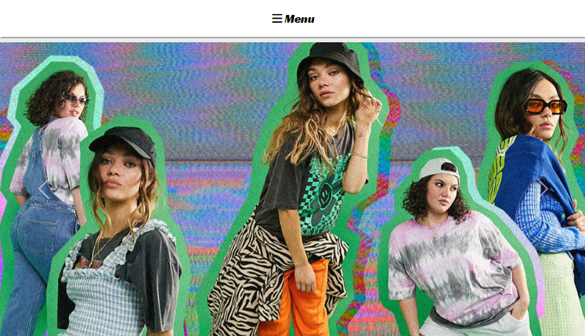

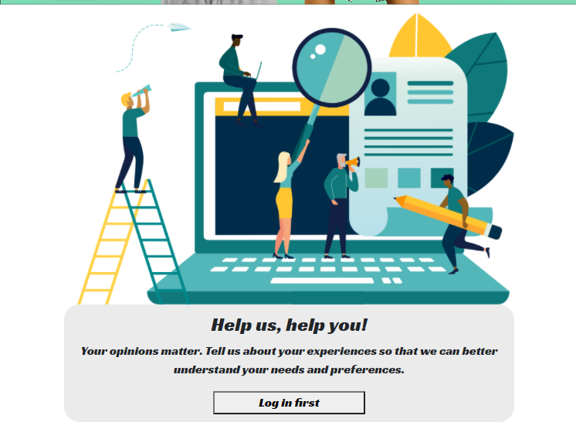

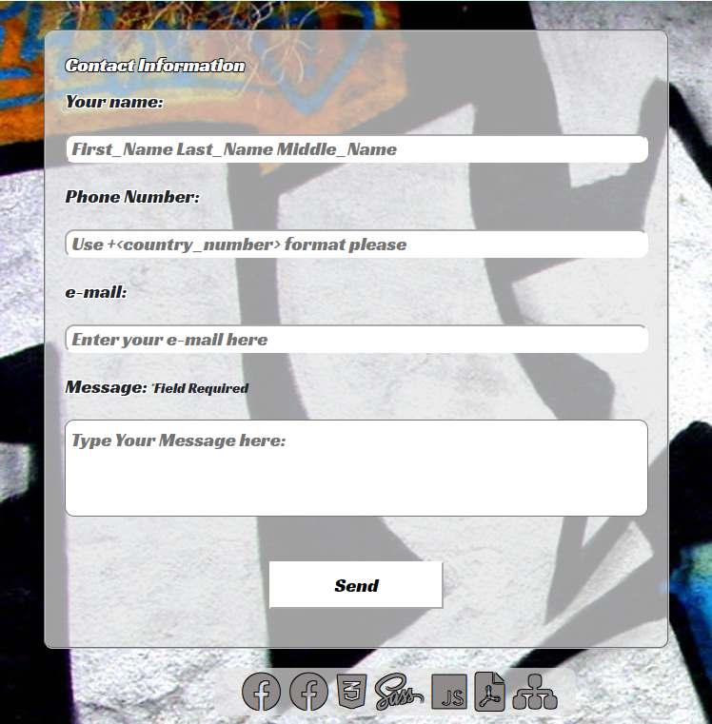

## 2.4 shop.php

Unutar radnje moguce je proizvode gledati na dva nacina. Korisnik ima opciju da promeni nacin prikaza u svakom trenutku. Sto se tice filtera on je prilicno jasan. Sve filter opcije su medjusobno povezane, i sa paginacijom, i nakon sto se jedna odradi druge ostaju upamcene. Sto se tice Korpe ona je odradjena tako da se dinamicki na klik ispisuje i brise. Obradjene su sve mogucnosti da ima/nema proizvoda, korisnik ce dobiti jasnu informaciju. Moze i da odradi kupovinu klikom na dugme, ali nece biti sacuvan u bazi. Otvorice mu se popup u kojem ce uneti podatke za kupovinu. Korpa ce se resetovati kao da je obavio kupovinu. Dobice feedback kada nesto doda u korpu da je dodao. Skoro sav ispis ovde je odradjen dinamicki iz baze i local storage-a. Verovatno ima jos nesto od funkcionalnosti sto sam zaboravio da napomenem ali kod ce biti dalje u dokumentaciji sa jasno naznacenim komentarima koji deo koda sluzi za sta.

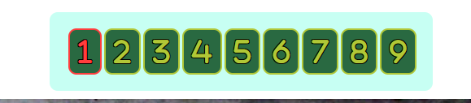

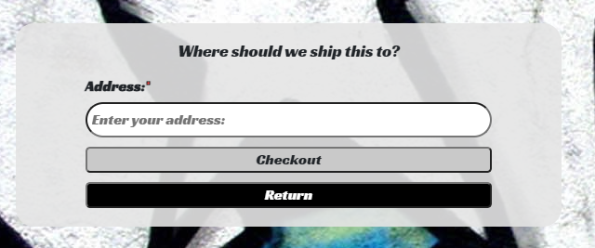

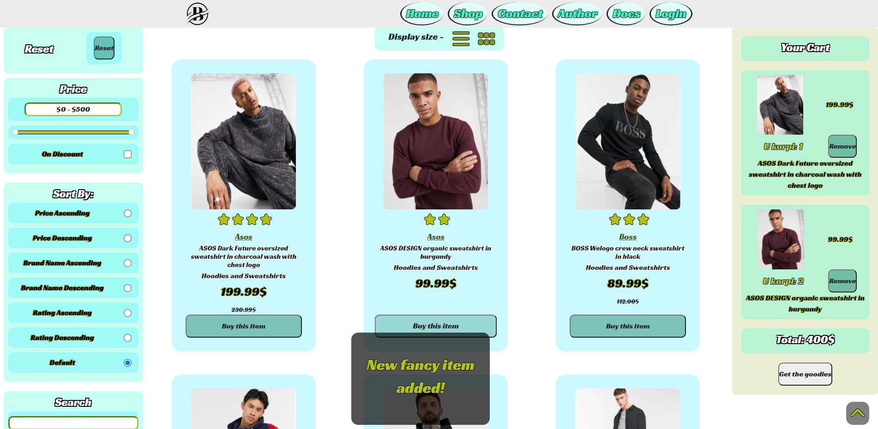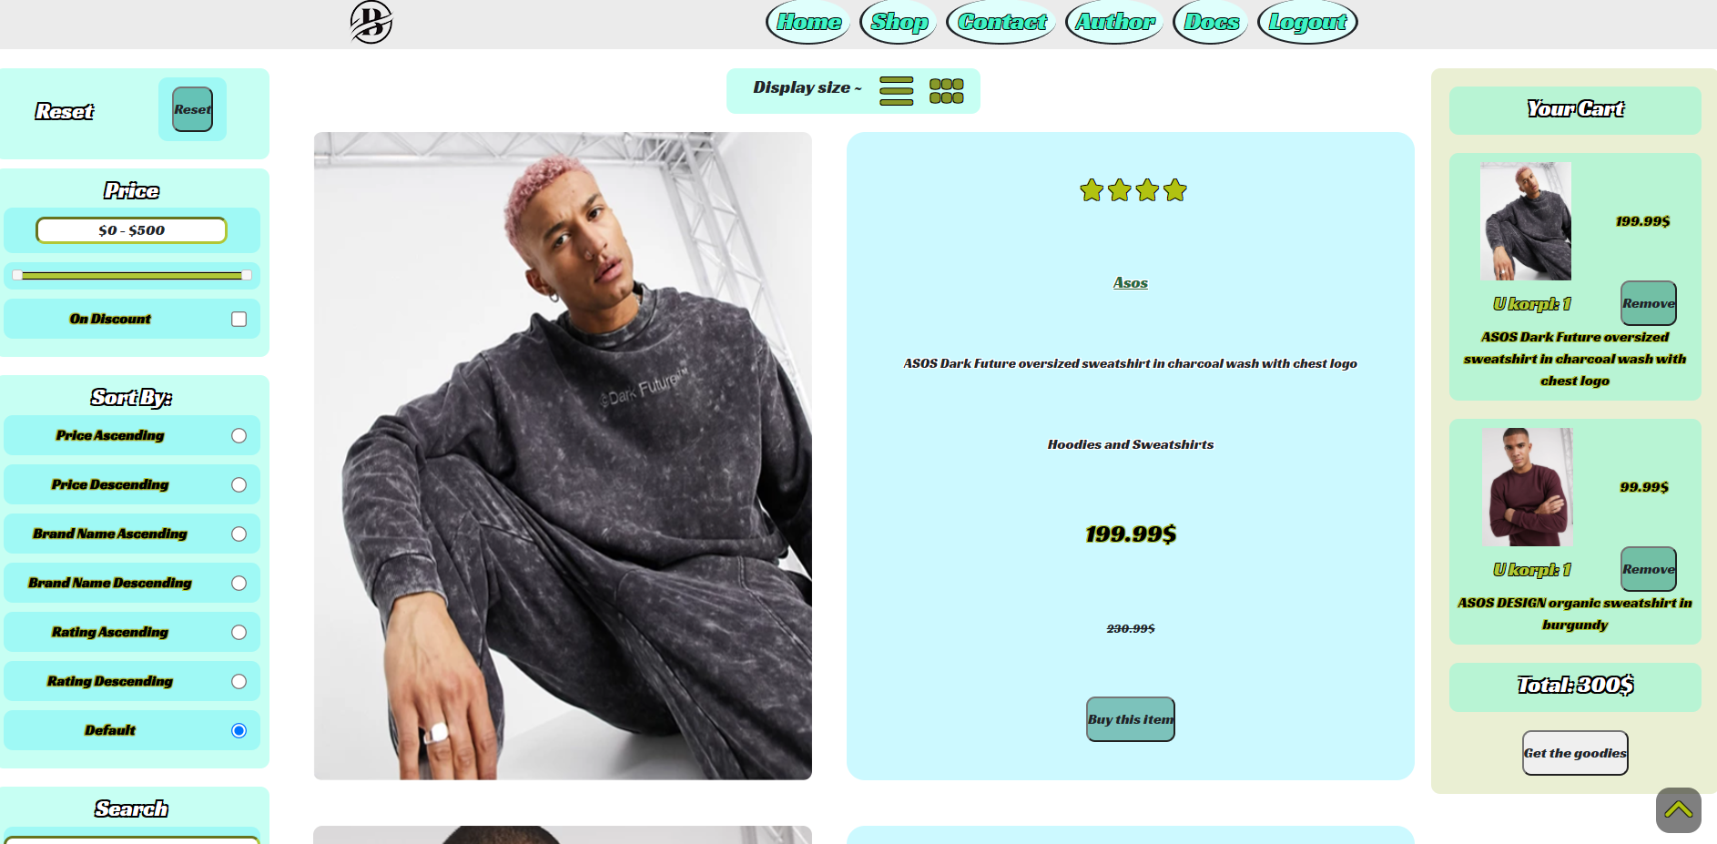

## 2.5 author.php

Opis o autoru.

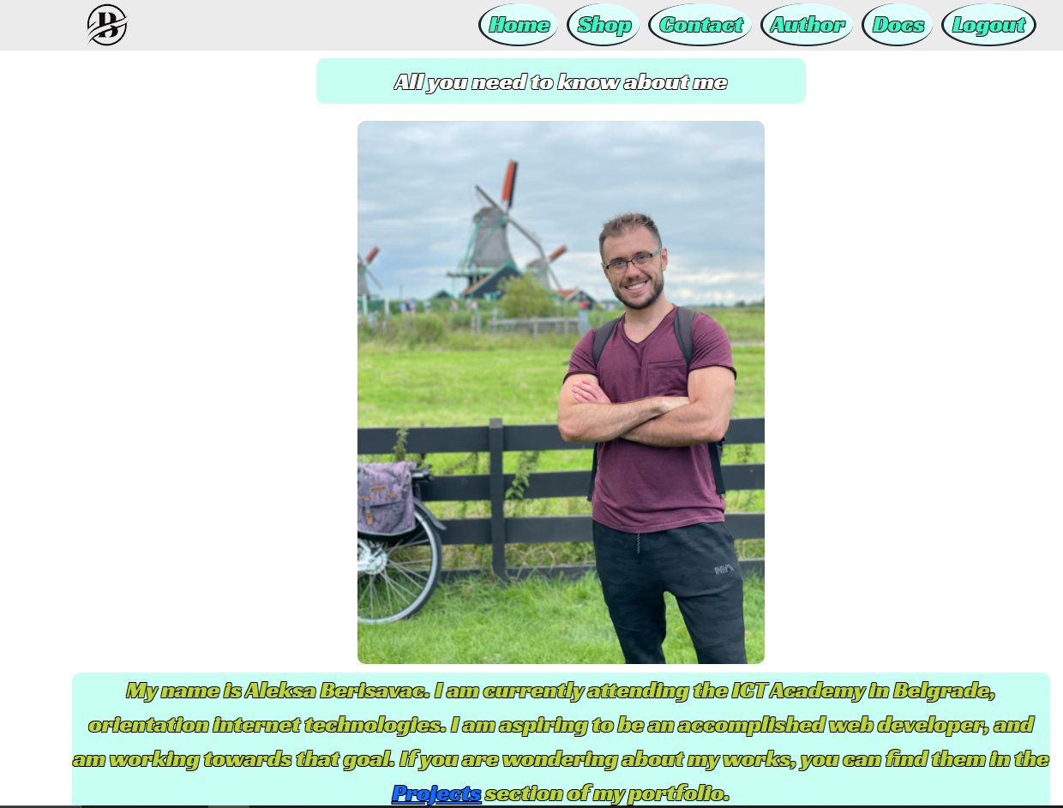

## 2.6 #Contact

Unutar futera nalazi se forma za slanje poruke, a ispod nje niz logoa koji vode ka source fajlovima koji su korišćeni u izradi ovog sajta. Što se tiče forme, od korisnika se očekuje da posalje neku poruku, ne zahteva se. Moze a i ne mora biti ulogovan, svejedno je. Ako se odluči da pošalje poruku proveriće se da li je nešto uneo u required input polje. Može, ali ne mora uneti svoje lične podatke, sa tim što ako ih unese moraju proći određeni proces provere što se postiže regularnim izrazima. Neće moći da pošalje poruku sa neispravnim podacima. Provera se vrsi i na frontu i na backu. Najmanja provera se vrši u samom mejlu gde se zahteva da ima samo ’@’ pošto mejlova ima svakakvih i tu jedino verifikacija pomaže. Ograničen je broj karaktera koji korisnik može da pošalje. Korisnik dobija feedback kada nešto upiše, koji mu govori da li je pogrešio i daje mu primer kako treba tačno uneti. Neke od ovih informacija su dodatno uslovljene tajmerima da se vrate na početno stanje nakon određenog vremena. Nakon što pritisne na dugme preko alerta mu se ispisuje da li je uspešno završio radnju i briše se već uneti sadrzaj za slučaj da hoće ponovo da unese nešto.

Kada posalje poruku ona se cuva u bazi podataka, moze biti anonimna.

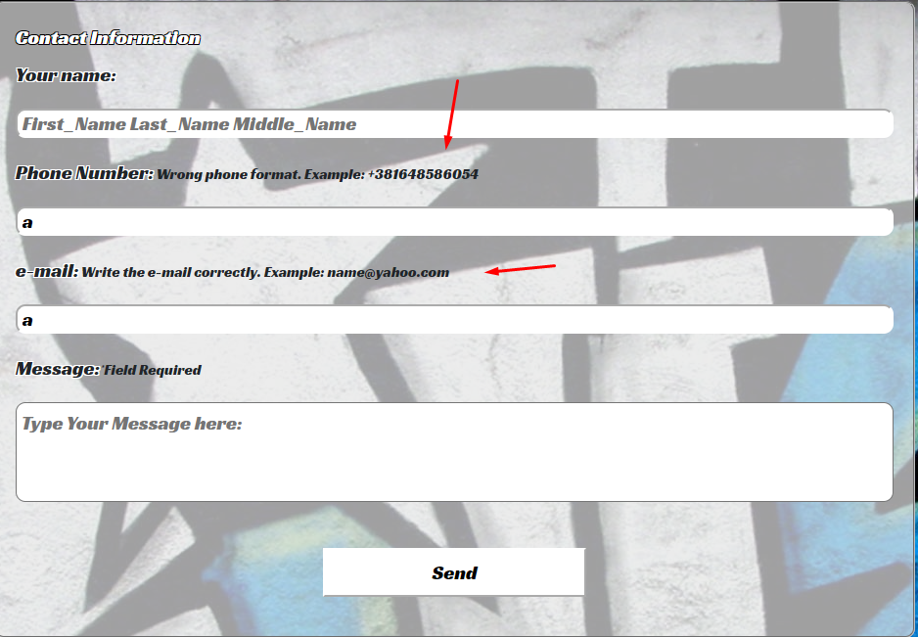

## 2.7 Anketa

Anketa je odradjena tako da se iz baze dohvataju ankete sa odgovorima, koje su medjusobno korelisane. Anketa moze biti aktivna i neaktivna na osnovu cega se prilagodjava ispis. Odgovori su korelisani medjusobno tabelama u bazi sa anketama i korisnicima. Ankete nisu anonimne i zahtevaju da korisnik bude ulogovan da bi mogao da glasa. Podaci se proveravaju i u frontu i u backu, takodje se jos neke stvari proveravaju, na primer.

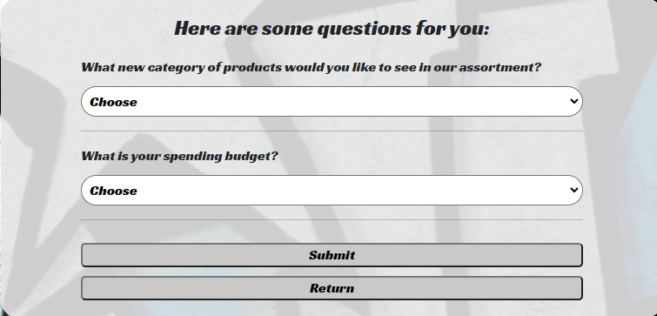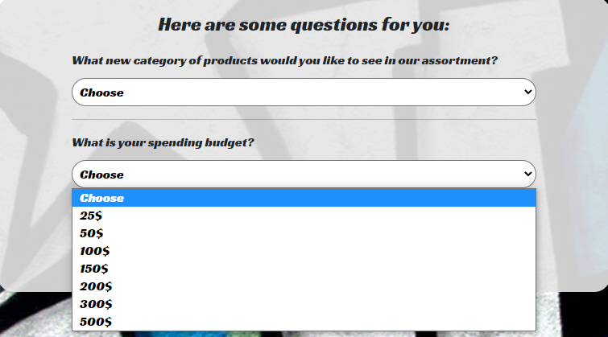

## 2.8 Logovanje

Kada se udje na logovanje, korisnik u slucaju da nije registrovan moze da se registruje. Ako je registrovan moze da se uloguje, a ako je zaboravio password moze da ga promeni. Ne moze da promeni password admina, cak ni admin to ne moze da uradi preko ove forme. 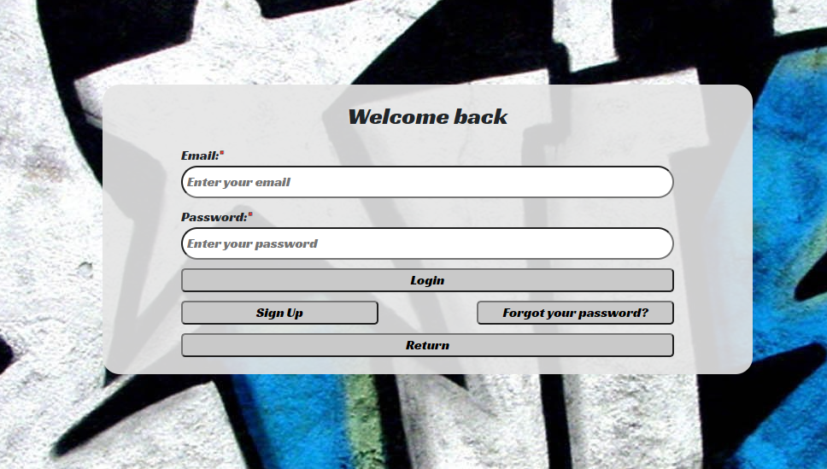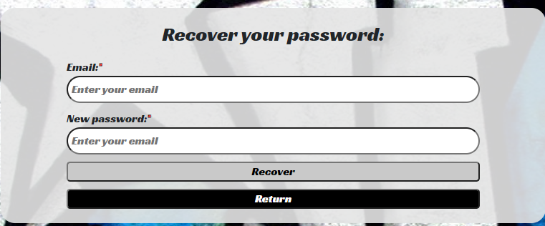

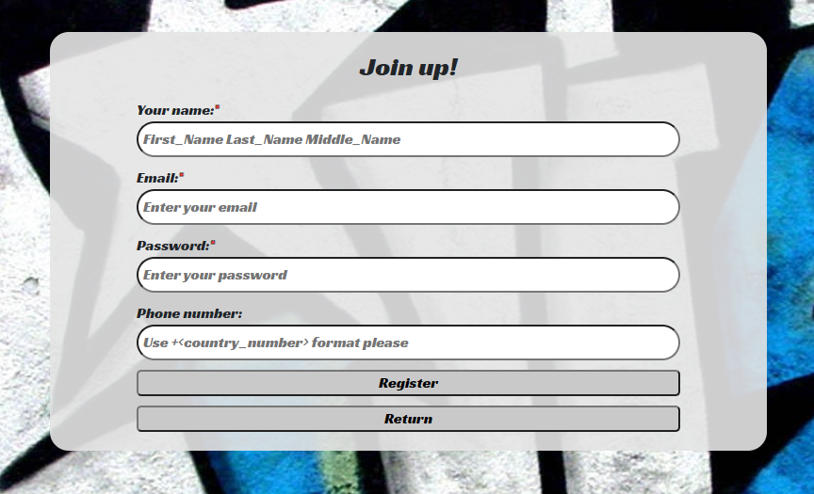

## 2.9 Organizacija Baze Podataka

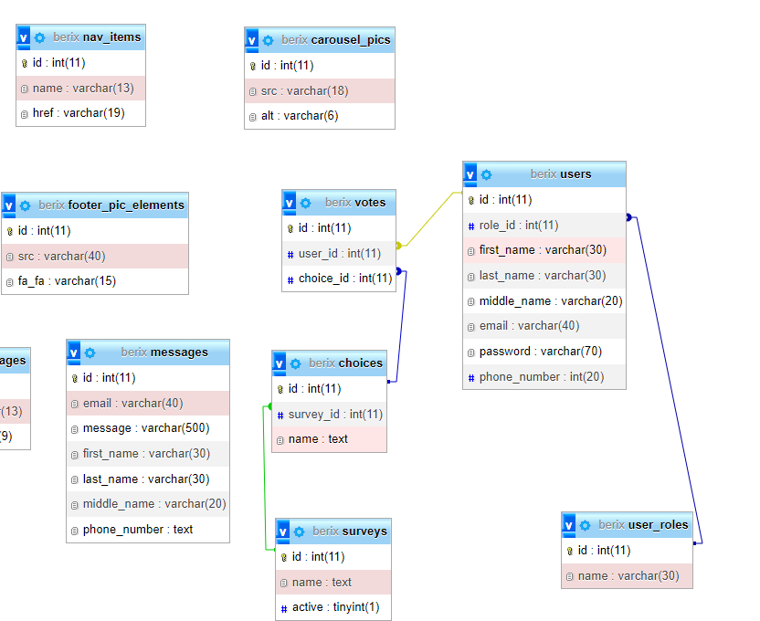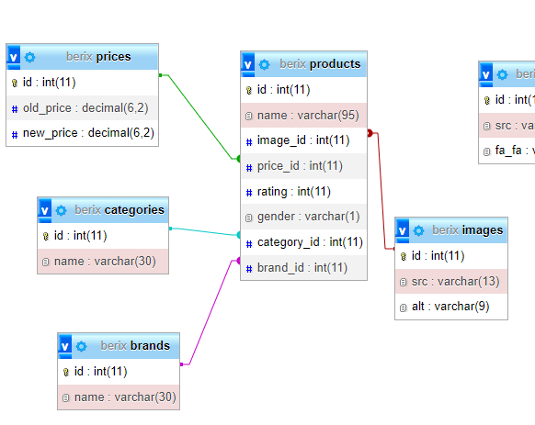

## 2.10 Organizacija fajlova

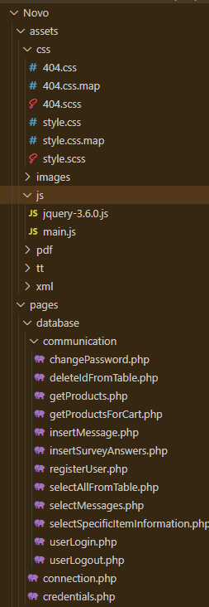

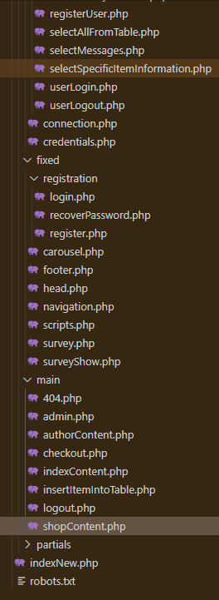

## 2.11 admin.php

Odradjen je prikaz poruka koje su skladistene u bazi preko kontakt forme, uskladjeno je sa upisivanjem u formi i birsanjem iz tabele na dugme delete, tako da se dinamicki promeni i pokaze stvarno stanje. Ispod je odradjen prikaz tabela prema selekciji. Moguce je brisati stavke klikom na dugme, edit i insert nisu odradjeni.

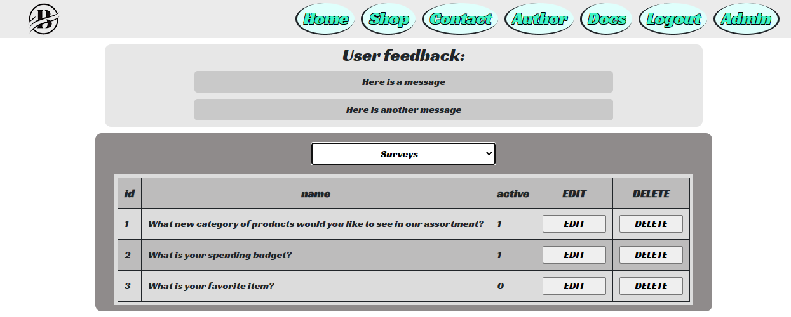

# 3. Kodovi

## 3.1. HTML/PHP:

### 3.1.1 index.php:

<?php

$index="pages/main/indexContent.php";

header('Location: '.$index);

?>

## 3.2 main

### 3.2.1 404.php

<!DOCTYPE html>

<html>

<head>

<meta charset="utf-8" />

<meta name="viewport" content="width=device-width, initial-scale=1, shrink-to-fit=no" />

<meta name="description" content="Not found." />

<meta name="keywords" content="error404 404 error notfound not found" />

<link rel="icon" href="../../assets/images/logoIcon.ico" type="image/x-icon" />

<title>Neki title</title>

<!-- Custom styles for this template -->

<link href="../../assets/css/404.css" rel="stylesheet" />

</head>

<body>

<div>

<aside><img src="https://s3-us-west-2.amazonaws.com/s.cdpn.io/4424790/Mirror.png" alt="404 Image" />

</aside>

<main>

<h1>Sorry!</h1>

<p>

Either you aren't cool enough to visit this page or it doesn't exist <em>. . . </em>

</p>

<button id="button-404">You can go now!</button>

</main>

</div>

<?php include("../fixed/scripts.php"); ?>

</body>

</html>

### 3.2.2 admin.php

<!DOCTYPE html>

<!DOCTYPE html>

<html>

<head>

<?php

$title="Admin Panel";

$keywords="berix shop programming web school project admin insert update delete";

$description="Edit database.";

require_once('../fixed/head.php');

?>

</head>

<body>

<!-- nav -->

<?php require_once('../fixed/navigation.php'); ?>

<header>

</header>

<main id="adminMain" class="width">

<div id="userMessages">

</div>

<div id="tablesWrapper">

<div id="selectTableToShow">

<select>

<option value="default">Select table to show:</option>

<?php

$tables = ["users", "products", "messages", "surveys", "choices", "categories", "brands", "nav_items", "images", "prices", "user_roles", "votes", "footer_pic_elements", "carousel_pics"];

foreach($tables as $table):

?>

<option value="<?= $table?>"><?= ucfirst($table)?></option>

<?php endforeach ?>

</select>

</div>

<span id="isDeleted"></span>

<div id="tableInformationWrapper">

</div>

</div>

</main>

<?php require_once('../fixed/scripts.php'); ?>

<footer id="contact" class="width">

<?php require_once('../fixed/footer.php'); ?>

</footer>

</body>

### 3.2.3 authorContent.php

<!DOCTYPE html>

<html>

<head>

<?php

$title="Berix - AUTHOR";

$keywords="berix shop programming author web school project";

$description="A little something about the author.";

require_once('../fixed/head.php');

?>

</head>

<body>

<!-- nav -->

<?php require_once('../fixed/navigation.php'); ?>

<header>

<?php require_once('../fixed/carousel.php'); ?>

</header>

<main id="authorMain" class="width">

<h3>All you need to know about me</h3>

<img src="../../assets/images/profile.jpg" alt="profil"/>

<div id="info">

<p>My name is Aleksa Berisavac. I am currently attending the ICT Academy in Belgrade, orientation internet technologies. I am aspiring to be an accomplished web developer, and am working towards that goal. If you are wondering about my works, you can find them in the <a href="http://beri-portfolio-js-jquery.synergize.co/?i=2#about">Projects</a> section of my portfolio. </p>

</div>

</main>

<?php require_once('../fixed/scripts.php'); ?>

<footer id="contact" class="width">

<?php require_once('../fixed/footer.php'); ?>

</footer>

</body>

</html>

### 3.2.4 checkout.php

<div id="checkout" class="allScreenPopUp">

<div class="credentialWrapper">

<h3>Where should we ship this to? </h3>

<form action="" method="POST" id="checkout" name="checkout">

<div class="popUpInput"><span id="inputAddress">*</span>

<label for="address">Address:</label>

<input type="text" placeholder="Enter your address: " id="address" name="address" />

</div>

</form>

<div class="buttonContainer"><span id="isDataValid"></span>

<button type="button" id="checkoutButton">Checkout</button>

</div>

<div class="buttonContainer">

<button type="button" id="back">Return</button>

</div>

</div>

</div>

### 3.2.5 indexContent.php

<!DOCTYPE html>

<html>

<head>

<?php

$title="Welcome To Berix";

$keywords="berix shop survey clothes programming";

$description="Index page for the beginning of your amasing experience!";

require_once('../fixed/head.php');

?>

</head>

<body>

<!-- Survey -->

<?php

if (isset($_SESSION["user"])) {

require_once('../fixed/surveyShow.php');

}

?>

<!-- nav -->

<?php require_once('../fixed/navigation.php'); ?>

<header>

<?php require_once('../fixed/carousel.php'); ?>

</header>

<main>

<?php require_once('../fixed/survey.php'); ?>

<div id="indexContent">

<h3>From rustic vests to slim jeans, you will immerse yourself in our clothing for hours.</h3>

<p>Berix is the #1 shop for all your outfitting needs. Keep your track with the times with our help, and in no time you will shine like a star.</p>

<a href="shopContent.php"><p>Start now!</p></a>

</div>

</main>

<?php require_once('../fixed/scripts.php'); ?>

<footer id="contact" class="width">

<?php require_once('../fixed/footer.php'); ?>

</footer>

</body>

</html>

### 3.2.6 insertItemIntoTable.php

<div id="insertIntoTable" class="allScreenPopUp">

<div id="dataWrapper">

<h3>Where should we ship this to? </h3>

<form action="" method="POST" id="checkout" name="checkout">

<div class="popUpInput"><span id="inputAddress">*</span>

<label for="address">Neko tekstualno input polje:</label>

<input type="text" placeholder="Enter your address: " id="address" name="address" />

</div>

</form>

<div class="buttonContainer"><span id="isDataValid"></span>

<button type="button" id="Update">Update</button>

</div>

<div class="buttonContainer">

<button type="button" id="back">Return</button>

</div>

</div>

</div>

### 3.2.7 logout.php

<?php

$logout="../database/communication/userLogout.php";

header('Location: '.$logout);

?>

### 3.2.8 shopContent.php

<!DOCTYPE html>

<html>

<head>

<link rel="stylesheet" href="//code.jquery.com/ui/1.12.1/themes/base/jquery-ui.css">

<link rel="stylesheet" href="https://maxcdn.bootstrapcdn.com/bootstrap/3.4.1/css/bootstrap.min.css">

<?php

$title = "Berix - SHOP";

$keywords = "berix shop survey clothes programming cart buy register";

$description = "Choose among the finest ware, fitting all your clothing needs!";

require_once('../fixed/head.php');

?>

</head>

<body>

<!-- nav -->

<div id="shoppingPopUp">

<p>New fancy item added!</p>

</div>

<div id="back-to-top"><a href="#"><i class="fas fa-chevron-up"></i></a></div>

<?php require_once('../fixed/navigation.php'); ?>

<header>

<?php require_once('../fixed/carousel.php'); ?>

</header>

<main id="shopMain" class="container-fluid">

<div class="row">

<aside id="filtersAside" class="col-sm-2 ">

<form method="get" action="obrada.php" name="filterForma">

<div class="filterProducts" id="resetFilter">

<h2>Reset</h2>

<div class="inputHolder">

<div class="col-sm-12"><input type="button" id="reset" name="reset" value="Reset" /></div>

</div>

</div>

<div class="filterProducts" id="priceRange">

<h2>Price</h2>

<div class="inputHolder">

<input type="text" id="amount" readonly>

</div>

<div class="inputHolder">

<div id="slider-range"></div>

</div>

<div class="inputHolder">

<div class="col-sm-10"><label for="onDiscount">On Discount</label></div>

<div class="col-sm-2"><input type="checkbox" id="onDiscount" name="onDiscount" value="1" /></div>

</div>

</div>

<div class="filterProducts" id="sort">

<h2>Sort By:</h2>

<div class="inputHolder">

<div class="col-sm-10"><label for="priceAsc">Price Ascending</label></div>

<div class="col-sm-2"><input type="radio" id="priceAsc" name="sort" value="priceAsc" /></div>

</div>

<div class="inputHolder">

<div class="col-sm-10"><label for="priceDesc">Price Descending</label></div>

<div class="col-sm-2"><input type="radio" id="priceDesc" name="sort" value="priceDesc" /></div>

</div>

<div class="inputHolder">

<div class="col-sm-10"><label for="brandAsc">Brand Name Ascending</label></div>

<div class="col-sm-2"><input type="radio" id="brandAsc" name="sort" value="brandAsc" /></div>

</div>

<div class="inputHolder">

<div class="col-sm-10"><label for="brandDesc">Brand Name Descending</label></div>

<div class="col-sm-2"><input type="radio" id="brandDesc" name="sort" value="brandDesc" /></div>

</div>

<div class="inputHolder">

<div class="col-sm-10"><label for="ratingAsc">Rating Ascending</label></div>

<div class="col-sm-2"><input type="radio" id="ratingAsc" name="sort" value="ratingAsc" /></div>

</div>

<div class="inputHolder">

<div class="col-sm-10"><label for="ratingDesc">Rating Descending</label></div>

<div class="col-sm-2"><input type="radio" id="ratingDesc" name="sort" value="ratingDesc" /></div>

</div>

<div class="inputHolder">

<div class="col-sm-10"><label for="default">Default</label></div>

<div class="col-sm-2"><input type="radio" id="default" name="sort" checked="checked" value="default" /></div>

</div>

</div>

<div class="filterProducts" id="search">

<h2>Search</h2>

<div class="inputHolder">

<input type="text" id="term">

</div>

</div>

<!-- CATEGORIES -->

<div class="filterProducts" id="filterCategories">

<div class="row">

<h2>Categories:</h2>

</div>

<?php

$query = "SELECT * FROM categories";

$result = $conn->query($query);

$categories = $result->fetchAll();

foreach ($categories as $category) :

?>

<div class="inputHolder">

<div class="col-sm-10"><label for="<?= $category->id ?>"><?= $category->name ?></label></div>

<div class="col-sm-2"><input type="checkbox" id="<?= $category->id ?>" name="<?= $category->id ?>" value="<?= $category->id ?>" /></div>

</div>

<?php endforeach ?>

</div>

<!-- BRANDS -->

<div class="filterProducts" id="filterBrands">

<div class="row">

<h2>Brands:</h2>

</div>

<?php

$query = "SELECT * FROM brands";

$result = $conn->query($query);

$brands = $result->fetchAll();

foreach ($brands as $brand) :

?>

<div class="inputHolder">

<div class="col-sm-10"><label for="<?= $brand->id ?>"><?= $brand->name ?></label></div>

<div class="col-sm-2"><input type="checkbox" id="<?= $brand->id ?>" name="<?= $brand->id ?>" value="<?= $brand->id ?>" /></div>

</div>

<?php endforeach ?>

</div>

</form>

</aside>

<div class=col-sm-8>

<div id="prSize" class="row">

<ul>

<li data-Id="1">

<p>Display size ~</p>

</li>

<li data-Id="2"><i class="fa-solid fa-bars"></i></li>

<li data-Id="3"><i class="fa fa-grip"></i></li>

</ul>

</div>

<!-- PRODUCTS -->

<div id="products" class="row">

<?php

function srcImage($product)

{

$src = "../../assets/images/Products/" . ($product->gender == "M" ? "Man" : "Woman") . "/" . $product->category_name . "/" . $product->src;

return $src;

var_dump($src);

}

function writeStars($stars)

{

$text = "";

for ($i = 0; $i < $stars; $i++) {

$text .= '<i class="fa fa-star" aria-hidden="true"></i>';

}

return $text;

}

$query = "SELECT *, p.name AS product_name, c.name AS category_name, b.name AS brand_name FROM

((((

products p INNER JOIN

categories c ON p.category_id=c.id) INNER JOIN

brands b ON p.brand_id=b.id) INNER JOIN

prices pr ON p.price_id=pr.id) INNER JOIN

images i ON p.image_id=i.id)

ORDER BY p.id ASC LIMIT 15";

$result = $conn->query($query);

$products = $result->fetchAll();

foreach ($products as $product) :

?>

<div class='row'>

<div class="col-sm-6">

<img src="<?= srcImage($product) ?>" alt="<?= $product->alt ?>" />

</div>

<div class="col-sm-6">

<p class="zvezde"><?= writeStars($product->rating)?></p>

<h3><?= $product->brand_name?></h3>

<h4><?= $product->product_name?></h4>

<h6><?= $product->category_name?></h6>

<p><?= $product->new_price?></p>

<s><?= $product->old_price != null ? ($product->old_price."$"):""?></s>

<input type="button" class="productButton" data-id="<?= $product->id ?>" name="productButton" value="Buy this item" />

</div>

</div>

<?php

endforeach;

?>

</div>

<div id="pagination" class="row">

<div>

<ul>

<?php

$query = "SELECT COUNT(*) AS product_number FROM products";

$result = $conn->query($query);

$numberOfProducts = $result->fetch();

$iterations = ceil($numberOfProducts->product_number / 15);

for ($i = 0; $i < $iterations; $i++) :

?>

<li <?php if ($i == 0) : ?> class="active-pagination" <?php endif ?>><i data-id="<?= $i + 1 ?>" class="fa-solid fa-<?= $i + 1 ?>"></i></li>

<?php endfor ?>

</ul>

</div>

</div>

</div>

<aside id="cartAside" class="col-sm-2">

</aside>

</div>

</main>

<?php require_once('../fixed/scripts.php'); ?>

<script src="https://maxcdn.bootstrapcdn.com/bootstrap/3.4.1/js/bootstrap.min.js"></script>

<script src="https://code.jquery.com/ui/1.12.1/jquery-ui.js"></script>

<footer id="contact" class="width">

<?php require_once('../fixed/footer.php'); ?>

</footer>

</body>

</html>

## 3.3 fixed

### 3.3.1 carousel.php

<?php

$getCarouselItemsQuery="SELECT * FROM carousel_pics";

$prepare = $conn->prepare($getCarouselItemsQuery);

$prepare->execute();

$carouselPics=$prepare->fetchAll();

?>

<div id="carouselExampleControls" class="carousel slide" data-bs-ride="carousel">

<div class="carousel-inner">

<?php foreach($carouselPics as $carouselPic): ?>

<div class="carousel-item <?php if($carouselPic->id==1) echo('active') ?>">

<img src="../../assets/images/Carousel/<?=$carouselPic->src?>" class="d-block w-100" alt="<?=$carouselPic->alt?>">

</div>

<?php endforeach ?>

</div>

<button class="carousel-control-prev" type="button" data-bs-target="#carouselExampleControls" data-bs-slide="prev">

<span class="carousel-control-prev-icon" aria-hidden="true"></span>

<span class="visually-hidden">Previous</span>

</button>

<button class="carousel-control-next" type="button" data-bs-target="#carouselExampleControls" data-bs-slide="next">

<span class="carousel-control-next-icon" aria-hidden="true"></span>

<span class="visually-hidden">Next</span>

</button>

</div>

### 3.3.2 footer.php

<form action="1.php" method="GET" name="contact-form" id="contact-form">

<fieldset>

<legend>Contact Information</legend>

<label for="name">Your name:</label><span id="inputName"></span>

<input type="text" placeholder="First_Name Last_Name Middle_Name" id="name" name="name" maxlength="30" />

<label for="phone">Phone Number:</label><span id="inputPhone"></span>

<input type="text" placeholder="Use +<country_number> format please" id="phone" name="phone" maxlength="15" />

<label for="emailaddress">e-mail:</label><span id="inputMail"></span>

<input type="email" id="emailAddress" name="emailAddress" placeholder="Enter your e-mail here">

<label for="message">Message:</label><span id="inputText"> *Field Required</span>

<textarea required="required" placeholder="Type Your Message here:" id="message" rows="3" cols="20" name="message"></textarea>

<div id="contactBtn">

<span id="contactButtonText"></span>

<input type="button" value="Send" id="buttonFooter" />

</div>

</fieldset>

</form>

<div id="icons">

<ul>

<?php

$getFooterItems="SELECT * FROM footer_pic_elements";

$prepare = $conn->prepare($getFooterItems);

$prepare->execute();

$footerItems=$prepare->fetchAll();

foreach($footerItems as $footerItem):

?>

<?php if($footerItem->src=="https://www.facebook.com/alexa.berisavac"): ?>

<a href="<?= $footerItem->src ?>"><li> <i class="<?= $footerItem->fa_fa ?>"></i> </li></a>

<?php endif ?>

<a href="../../<?= $footerItem->src ?>"><li> <i class="<?= $footerItem->fa_fa ?>"></i> </li></a>

<?php endforeach ?>

</ul>

</div>

### 3.3.3 head.php

<?php session_start(); ?>

<meta charset="utf-8" />

<meta name="viewport" content="width=device-width, initial-scale=1, shrink-to-fit=no" />

<meta name="description" content="<?= $description ?>" />

<meta name="keywords" content="<?= $keywords ?>" />

<link rel="icon" href="../../assets/images/logoIcon.ico" type="image/x-icon" />

<script src="https://kit.fontawesome.com/9d68c2c5c8.js" crossorigin="anonymous"></script>

<title><?= $title ?></title>

<!-- Custom styles for this template -->

<link href="https://cdn.jsdelivr.net/npm/bootstrap@5.1.3/dist/css/bootstrap.min.css" rel="stylesheet" integrity="sha384-1BmE4kWBq78iYhFldvKuhfTAU6auU8tT94WrHftjDbrCEXSU1oBoqyl2QvZ6jIW3" crossorigin="anonymous">

<link href="../../assets/css/style.css" rel="stylesheet" />

<?php

require_once("../database/connection.php");

?>

### 3.3.4 navigation.php

<?php

$getNavItemsQuery = "SELECT * FROM nav_items";

$prepare = $conn->prepare($getNavItemsQuery);

$prepare->execute();

$navItems = $prepare->fetchAll();

if (!isset($_SESSION["user"])) {

require_once('../fixed/registration/login.php');

require_once('../fixed/registration/register.php');

require_once('../fixed/registration/recoverPassword.php');

} else{

$path=explode("/", $_SERVER["REQUEST_URI"]);

if(($path[count($path)-1]=="shopContent.php")) require_once('../main/checkout.php');

if(($path[count($path)-1]=="admin.php")) require_once('../main/insertItemIntoTable.php');

}

?>

<nav>

<a href="indexContent.php">

<div id="logo"><img src="../../assets/images/navLogo.png" /></div>

</a>

<div id="navMenu">

<button id="btnMenu"><i class="fa fa-bars"></i> Menu</button>

<ul>

<?php

$path=explode("/", $_SERVER["REQUEST_URI"]);

foreach ($navItems as $navItem) :

?>

<?php

if (isset($_SESSION["user"]) && $navItem->name == "Login") continue;

if (!isset($_SESSION["user"]) && $navItem->name == "Logout") continue;

if ((!isset($_SESSION["user"]) || $_SESSION["user"]->role_id!=4) && $navItem->name == "Admin") continue;

?>

<?php

if($path[count($path)-1]!=$navItem->href):

?>

<a href="<?= $navItem->href ?>">

<li><?= $navItem->name ?></li>

</a>

<?php else: ?>

<a href="#">

<li><?= $navItem->name ?></li>

</a>

<?php endif; endforeach ?>

</ul>

</div>

</nav>

### 3.3.5 scripts.php

<script src="https://cdn.jsdelivr.net/npm/bootstrap@5.1.3/dist/js/bootstrap.bundle.min.js" integrity="sha384-ka7Sk0Gln4gmtz2MlQnikT1wXgYsOg+OMhuP+IlRH9sENBO0LRn5q+8nbTov4+1p" crossorigin="anonymous"></script>

<script type="text/javascript" src="../../assets/js/jquery-3.6.0.js"></script>

<script type="text/javascript" src="../../assets/js/main.js"></script>

<script src="https://cdnjs.cloudflare.com/ajax/libs/crypto-js/3.1.2/rollups/md5.js"></script>

### 3.3.6 survey.php

<div id="surveyIndexWrapper">

<div id="indexsurveyImg">

<img src="../../assets/images/survey.png" alt="survey.png"/>

</div>

<div id="indexsurveyDescription">

<div>

<h3>Help us, help you! </h3>

<p>Your opinions matter. Tell us about your experiences so that we can better understand your needs and preferences.</p>

<?php if(isset($_SESSION['user'])): ?> <button type="button" id="indexShowsurvey">Take a vote!</button> <?php endif ?>

<?php if(!isset($_SESSION['user'])): ?> <button type="button" id="loginToVote">Log in first</button> <?php endif ?>

</div>

</div>

</div>

### 3.3.7 surveyShow.php

<div id="showsurvey" class="allScreenPopUp">

<div class="credentialWrapper">

<h4>Here are some questions for you: </h4>

<div id="surveysHolder">

<?php

$query = "SELECT * FROM surveys WHERE active=true";

$result = $conn->query($query);

$surveys = $result->fetchAll();

$query = "SELECT * FROM surveys s INNER JOIN choices c ON s.id=c.survey_id WHERE s.active=true";

$result = $conn->query($query);

$choices = $result->fetchAll();

$query = "SELECT * FROM votes WHERE user_id=".$_SESSION['user']->id;

$result = $conn->query($query);

$votes = $result->fetchAll();

foreach($surveys as $survey){

$didNotVote=true;

if(count($votes)>0){

foreach($votes as $vote){

if ($vote->user_id==$_SESSION['user']->id){

$voteSurvey=null;

foreach($choices as $choice){

if($choice->id==$vote->choice_id) $voteSurvey=$choice->survey_id;

}

if($survey->id==$voteSurvey){

$didNotVote=false;

break;

}

}

}

}

if(!$didNotVote) continue;

$idsurvey=$survey->id;

$namesurvey=$survey->name;

echo("<label for='$idsurvey'>$namesurvey</label>");

echo("<select name='$idsurvey'>");

echo("<option value='0'>Choose </option>");

foreach($choices as $choice){

$idChoice=$choice->id;

if($survey->id!=$choice->survey_id) continue;

$nameChoice=$choice->name;

echo("<option value='$idChoice'>$nameChoice</option>");

}

echo("</select><hr/>");

}

?>

</div>

<div class="buttonContainer"><span id="isSurveyDataValid"></span>

<button type="button" id="submitSurveyAnswers">Submit</button>

</div>

<div class="buttonContainer">

<button type="button" class="backToMain">Return</button>

</div>

</div>

</div>

## 3.4 fixed/registration

### 3.4.1 login.php

<div id="logIn" class="allScreenPopUp">

<div class="credentialWrapper">

<h3>Welcome back</h3>

<form action="" method="POST" id="login-form" name="login-form">

<div class="popUpInput">

<label for="loginEmail">Email: </label><span id="inputLoginEmail">*</span>

<input type="text" placeholder="Enter your email" id="loginEmail" name="loginEmail" />

</div>

<div class="popUpInput">

<label for="loginPassword">Password: </label><span id="inputLoginPassword">*</span>

<input type="password" placeholder="Enter your password" id="loginPassword" name="loginPassword" />

</div>

</form>

<div class="buttonContainer">

<span id="isLoginValid"></span>

<button type="button" id="login">Login</button>

</div>

<div id="register-forgotPassword">

<button type="button" id="goRegister">Sign Up</button>

<button type="button" id="forgotPassword">Forgot your password?</button>

</div>

<div class="buttonContainer">

<button type="button" id="back">Return</button>

</div>

</div>

</div>

### 3.4.1 recoverPassword.php

<div id="recoverPassword" class="allScreenPopUp">

<div class="credentialWrapper">

<h3>Recover your password: </h3>

<form action="" method="POST" id="recover-password" name="recover-password">

<div class="popUpInput"><span id="inputRecoveryEmail">*</span>

<label for="recoveryEmail">Email: </label>

<input type="text" placeholder="Enter your email" id="recoveryEmail" name="recoveryEmail" />

</div>

<div class="popUpInput"><span id="inputRecoveryPassword">*</span>

<label for="recoveryPassword">New password: </label>

<input type="password" placeholder="Enter your email" id="recoveryPassword" name="recoveryPassword" />

</div>

</form>

<div class="buttonContainer"><span id="isDataValid"></span>

<button type="button" id="recoverPass">Recover</button>

</div>

<div class="buttonContainer">

<button type="button" class="backToMain">Return</button>

</div>

</div>

</div>

### 3.4.1 register.php

<div id="register" class="allScreenPopUp">

<div class="credentialWrapper">

<h3>Join up!</h3>

<form action="" method="POST" id="register-form" name="register-form">

<div class="popUpInput">

<label for="registerName">Your name: </label><span id="inputRegisterName">*</span>

<input type="text" placeholder="First_Name Last_Name Middle_Name" id="registerName" name="registerName" />

</div>

<div class="popUpInput">

<label for="registerEmail">Email: </label><span id="inputRegisterMail">*</span>

<input type="text" placeholder="Enter your email" id="registerEmail" name="registerEmail" />

</div>

<div class="popUpInput">

<label for="registerPassword">Password: </label><span id="inputRegisterPassword">*</span>

<input type="password" placeholder="Enter your password" id="registerPassword" name="registerPassword" />

</div>

<div class="popUpInput">

<label for="registerPhoneNumber">Phone number: </label><span id="inputRegisterPhone"></span>

<input type="text" placeholder="Use +<country_number> format please" id="registerPhoneNumber" name="registerPhoneNumber" />

</div>

</form>

<div class="buttonContainer">

<span id="isRegistrationValid"></span>

<button type="button" id="registerUser">Register</button>

</div>

<div class="buttonContainer">

<button type="button" class="backToMain">Return</button>

</div>

</div>

</div>

## 3.5 database

### 3.5.1 connection.php

<?php

try{

require_once("credentials.php");

$conn = new PDO("mysql:host=$dbServer;dbname=$dbName", $dbUsername, $dbPassword);

$conn->setAttribute(PDO::ATTR_DEFAULT_FETCH_MODE, PDO::FETCH_OBJ);

$conn->setAttribute(PDO::ATTR_ERRMODE, PDO::ERRMODE_EXCEPTION);

}

catch(PDOException $e){

echo("Doslo je do greske pri konekciji sa bazom. Greska je: ".$e->getmessage());

}

?>

### 3.5.2 credentials.php

<?php

//$dbName="epiz_31275334_berix";

//$dbServer="sql310.epizy.com";

//$dbUsername="epiz_31275334";

//$dbPassword="FmZjifbOgecud";

$dbName="berix";

$dbServer="localhost";

$dbUsername="root";

$dbPassword="";

?>

## 

## 3.6 database/communication

### 3.6.1 changePassword.php

NAPOMENA: Zakomentarisao sam deo za promenu sifre da se sifra ne bi zaista promenila.

<?php

session_start();

include('../connection.php');

$errors = [];

function returnErrors($errors)

{

$message = "";

foreach ($errors as $error) {

$message .= $error . " ";

}

header("Content-Type: application/json");

http_response_code(422);

echo json_encode(["message" => $message]);

die();

}

//provera emaila

$reMail = "/^\S{1,15}@\S{1,15}$/";

$email = null;

if (isset($_POST['email']) && !empty($_POST['email'])) {

$email = $_POST['email'];

if (!preg_match($reMail, $email)) {

array_push($errors, "Email must be inserted correctly!");

} {

$email = addslashes($email);

}

} else {

array_push($errors, "Email must be inserted!");

}

//provera passworda

$rePassword = "/^(?=.*[a-z])(?=.*[A-Z])(?=.*\d)(?=.*[@$!%*?&])[A-Za-z\d@$!%*?&]{8,}$/";

$password = null;

if (isset($_POST['password']) && !empty($_POST['password'])) {

$password = $_POST['password'];

if (!preg_match($rePassword, $password)) {

array_push($errors, "Password must be inserted correctly!");

} else {

$password = addslashes(md5($password));

}

} else {

array_push($errors, "Password must be inserted!");

}

if (count($errors) > 0) returnErrors($errors);

//da li postoji takav user

$query = "SELECT id, role_id FROM users WHERE email=:email";

$prepare = $conn->prepare($query);

$prepare->bindParam(":email", $email);

$prepare->execute();

$user = $prepare->fetch();

if ($user == false) {

header("Content-Type: application/json");

http_response_code(404);

echo json_encode(['message' => 'User with said email does not exist!']);

die();

}

$admin="admin";

$query = "SELECT id FROM user_roles WHERE name=:name";

$prepare = $conn->prepare($query);

$prepare->bindParam(":name", $admin);

$prepare->execute();

$adminId = $prepare->fetch();

if ($user->role_id == $adminId->id) {

header("Content-Type: application/json");

http_response_code(403);

echo json_encode(['message' => 'User with said email is an administrator!']);

die();

}

// $query = "UPDATE users SET password=:password WHERE email=:email";

// $prepare = $conn->prepare($query);

// $prepare->bindParam(":password", $password);

// $prepare->bindParam(":email", $email);

// $prepare->execute();

header("Content-Type: application/json");

http_response_code(200);

echo json_encode(['message' => 'You have changed your password! You can now go back to login. ']);

### 3.6.2 deleteIdFromTable.php

<?php

$table=$_GET["table"];

$id=$_GET["id"];

include("../connection.php");

$query="DELETE FROM ".$table." WHERE id=:id";

$prepare=$conn->prepare($query);

$prepare->bindParam(":id", $id);

try{

$prepare->execute();

header("Content-Type: application/json");

echo json_encode(["message"=>"Success!"]);

}

catch(PDOException $e){

header("Content-Type: application/json");

http_response_code(404);

echo json_encode(["message"=>"There was an error with your request. This item might be referenced by another from different table or the item might not exist in database."]);

}

?>

### 3.6.3 getProducts.php

<?php

include("../connection.php");

$productsToShowOnPage= $_GET["displayMethod"]==2?6:15;

if($_GET["pagination"]>4&&$productsToShowOnPage==15) $_GET["pagination"]=1;

function getAllProductsSorted()

{

global $conn;

$sortType=$_GET['sort'];

$value = null;

$type =null;

$query = "SELECT *, p.name AS product_name, c.name AS category_name, b.name AS brand_name FROM

((((

products p INNER JOIN

categories c ON p.category_id=c.id) INNER JOIN

brands b ON p.brand_id=b.id) INNER JOIN

prices pr ON p.price_id=pr.id) INNER JOIN

images i ON p.image_id=i.id)";

$prepare = $conn->prepare($query);

$prepare->execute();

$products = $prepare->fetchAll();

function strCmpGreater($a, $b) {

return strcmp($a->name, $b->name);

}

function strCmpLesser($a, $b) {

return -strcmp($a->name, $b->name);

}

function valueGreater($a, $b){

return $a->new_price>$b->new_price?1:-1;

}

function valueLesser($a, $b){

return $a->new_price<$b->new_price?1:-1;

}

function ratingGreater($a, $b){

return $a->rating>$b->rating?1:-1;

}

function ratingLesser($a, $b){

return $a->rating<$b->rating?1:-1;

}

if ($sortType=="default"){

$products=$products;

} else if($sortType=="priceAsc"){

usort($products, "valueGreater");

}else if($sortType=="priceDesc"){

usort($products, "valueLesser");

}else if($sortType=="brandAsc"){

usort($products, "strCmpGreater");

}else if($sortType=="brandDesc"){

usort($products, "strCmpLesser");

}else if($sortType=="ratingAsc"){

usort($products, "ratingGreater");

}else if($sortType=="ratingDesc"){

usort($products, "ratingLesser");

};

return $products;

}

$products = getAllProductsSorted();

//FILTRIRANJE PO KATEGORIJAMA

function filterProductsByCategories($products){

$arrOfCategoriesToFilter = explode(",", $_GET["categories"]);

$helpingArray=[];

foreach($products as $product){

if(in_array($product->category_id, $arrOfCategoriesToFilter)){

array_push($helpingArray, $product);

}

}

return $helpingArray;

}

if($_GET["categories"]!=""){

$products = filterProductsByCategories($products);

}

//FILTRIRANJE PO BRENDOVIMA

function filterProductsByBrands($products){

$arrOfBrandsToFilter = explode(",", $_GET["brands"]);

$helpingArray=[];

foreach($products as $product){

if(in_array($product->brand_id, $arrOfBrandsToFilter)){

array_push($helpingArray, $product);

}

}

return $helpingArray;

}

if($_GET["brands"]!=""){

$products = filterProductsByBrands($products);

}

//FILTRIRANJE PO TERMINU PRETRAGE

function filterProductsByTerm($products){

$helpingArray=[];

$searchTerm = $_GET["searchTerm"];

foreach($products as $product){

if(strpos(strtolower($product->product_name) , strtolower($searchTerm))){

array_push($helpingArray, $product);

}

}

return $helpingArray;

}

if($_GET["searchTerm"]!=""){

$products = filterProductsByTerm($products);

}

//FILTRIRANJE PO POPUSTU (samo oni na popustu se prikazuju)

function filterProductsByDiscount($products){

$helpingArray=[];

foreach($products as $product){

if($product->old_price){

array_push($helpingArray, $product);

}

}

return $helpingArray;

}

if($_GET['onDiscount']=="true"){

$products=filterProductsByDiscount($products);

}

//FILTRIRANJE PO SLAJDERU

function filterProductsBySlider($products){

$values = explode(",", $_GET['slider']);

$helpingArray=[];

foreach($products as $product){

if($product->new_price>$values[0] && $product->new_price<$values[1]){

array_push($helpingArray, $product);

}

}

return $helpingArray;

}

if($_GET['slider']!=""){

$products = filterProductsBySlider($products);

}

//PAGINATION - RADI SE NA KRAJU POSLE SVIH FILTERA!

function paginateProducts($products)

{

global $productsToShowOnPage;

$page = $_GET["pagination"];

$startingProductToShow = $page * $productsToShowOnPage -$productsToShowOnPage;

$helpingArray = [];

$lastProductToShow = ((count($products) - $productsToShowOnPage * ($page-1)) > $productsToShowOnPage) ? $page * $productsToShowOnPage : count($products);

for ($i = $startingProductToShow; $i < $lastProductToShow; $i++) {

array_push($helpingArray, $products[$i]);

}

return $helpingArray;

}

$totalNumberOfProducts = count($products);

if($products){

$products = paginateProducts($products);

}

header("Content-Type: application/json");

echo json_encode(["products" => $products, "numberOfProducts"=> $totalNumberOfProducts]);

### 3.6.4 getProductsForCart.php

<?php

include("../connection.php");

$productIds=$_GET['productIds'];

$inStatement = "";

for($i=0;$i<count($productIds);$i++){

$i==0?$inStatement.=$productIds[$i]:$inStatement.=", ".$productIds[$i];

}

$query="SELECT *, p.name AS product_name, c.name AS category_name, b.name AS brand_name FROM

((((

products p INNER JOIN

categories c ON p.category_id=c.id) INNER JOIN

brands b ON p.brand_id=b.id) INNER JOIN

prices pr ON p.price_id=pr.id) INNER JOIN

images i ON p.image_id=i.id)

WHERE p.id IN (".$inStatement.")

";

$result = $conn->query($query);

$products=$result->fetchAll();

header("Content-Type: application/json");

echo json_encode(["products"=>$products]);

?>

### 3.6.5 insertMessage.php

<?php

$errors= [];

function returnErrors($errors){

header("Content-Type: application/json");

echo json_encode($errors);

}

//provera postojanja poruke

if(!isset($_GET['message'])||empty($_GET['message'])){

array_push($errors, "Poruka nije setovana!");

returnErrors($errors);

} else{

$message=$_GET['message'];

if(strlen($message)>500){

array_push($errors, "Poruka ne sme biti duza od 500 karaktera!!");

returnErrors($errors);

}

$message=addslashes($message);

}

//provera imena posiljaoca

$reIme = "/^[A-Z][a-z]{1,11}(\s[A-Z][a-z]{1,11}){1,2}/";

$name=null;

$first_name=null;

$last_name=null;

$middle_name=null;

if(isset($_GET['full_name'])&&!empty($_GET['full_name'])){

$name = $_GET['full_name'];

if(!preg_match($reIme, $name)){

array_push($errors, "Ime, ako postoji, mora biti ispravno uneto!");

returnErrors($errors);

}

$names = explode(" ", $name);

$first_name=addslashes($names[0]);

$last_name=addslashes($names[1]);

$middle_name==null?null:addslashes($names[2]);

}

//provera broja telefona

$reBroj = "/(^\+[\d]{10,13})|(^\+[\d]{3,5}(\s\d{2,4}){1,4})/";

$phone_number=null;

if(isset($_GET['phone_number'])&&!empty($_GET['phone_number'])){

$phone_number = $_GET['phone_number'];

if(!preg_match($reBroj, $phone_number)){

array_push($errors, "Broj nije ispravno unet");

returnErrors($errors);

}

$phone_number = addslashes($phone_number);

}

//provera emaila

$reMail = "/^\S{1,15}@\S{1,15}$/";

$email=null;

if(isset($_GET['email'])&&!empty($_GET['email'])){

$email = $_GET['email'];

if(!preg_match($reMail, $email)){

array_push($errors, "Email nije ispravno unet");

returnErrors($errors);

}

$email = addslashes($email);

}

include('../connection.php');

$query = "INSERT INTO messages (email, message, first_name, last_name, middle_name, phone_number) VALUES(:email, :message, :first_name, :last_name, :middle_name, :phone_number)";

$prepare=$conn->prepare($query);

$prepare->bindParam(':email', $email);

$prepare->bindParam(':message', $message);

$prepare->bindParam(':first_name', $first_name);

$prepare->bindParam(':last_name', $last_name);

$prepare->bindParam(':middle_name', $middle_name);

$prepare->bindParam(':phone_number', $phone_number);

$prepare->execute();

header("Content-Type: application/json");

echo json_encode(["poruka"=>"Uspesno uneta poruka u bazu!"]);

### 3.6.6 insertSurveyAnswers.php

<?php

session_start();

include('../connection.php');

function returnError($message, $status){

header("Content-Type: application/json");

http_response_code($status);

echo json_encode(['message' => $message]);

die();

}

if (checkIfUserSentNoChoiceAndArray()){

returnError("You did not send any vote for any surveys!", 422);

};

$surveys = $_GET["array"];

$userId = $_SESSION['user']->id;

function checkIfUserSentNoChoiceAndArray(){

if( !isset($_GET["array"]) || empty($_GET["array"] ))

{

return true;

} else{

return false;

}

};

function checkIfSurveyExistsInDb($surveyId, $conn){

$query="SELECT * FROM surveys WHERE id=$surveyId";

$result = $conn->query($query);

$survey = $result->fetch();

if($survey) return true; else return false;

}

function checkIfChoiceExistsInDb($choiceId, $conn){

$query="SELECT * FROM choices WHERE id=$choiceId";

$result = $conn->query($query);

$choice = $result->fetch();

if($choice) return true; else return false;

}

function checkIfChoiceIsConnectedToSurvey($surveyId, $choiceId, $conn){

$query="SELECT * FROM choices WHERE id=$choiceId AND survey_id=$surveyId";

$result = $conn->query($query);

$connection = $result->fetch();

if($connection) return true; else return false;

}

function checkIfUserAlreadyVoted($userId, $choiceId, $conn){

$query="SELECT * FROM votes WHERE id=$userId AND choice_id=$choiceId";

$result = $conn->query($query);

$connection = $result->fetch();

if(!$connection) return true; else return false;

}

foreach($surveys as $survey){

if (!checkIfSurveyExistsInDb($survey[0], $conn)){

returnError("You tried to answer a survey that does not exist!", 404);

};

if (!checkIfChoiceExistsInDb($survey[1], $conn)){

returnError("You have chosen something that does not exist!", 404);

};

if (!checkIfChoiceIsConnectedToSurvey($survey[0], $survey[1], $conn)){

returnError("Choice you chose does not correspond to the survey you answered. Please contact administrator.", 422);

};

if (!checkIfUserAlreadyVoted($userId, $survey[1], $conn)){

returnError("You have already voted for one of the surveys!", 422);

};

$query="INSERT INTO votes (user_id, choice_id) VALUES (:user_id, :choice_id)";

$prepare = $conn->prepare($query);

$prepare->bindParam(":user_id", $userId);

$prepare->bindParam(":choice_id", $survey[1]);

$prepare->execute();

}

header("Content-Type: application/json");

http_response_code(200);

echo json_encode(['message' => "You have succesfully voted!"]);

?>

### 3.6.7 registerUser.php

<?php

session_start();

include('../connection.php');

$errors = [];

function returnErrors($errors)

{

$message = "";

foreach ($errors as $error) {

$message .= $error . " ";

}

header("Content-Type: application/json");

http_response_code(422);

echo json_encode(["message" => $message]);

die();

}

//provera imena korisnika

$reIme = "/^[A-Z][a-z]{1,11}(\s[A-Z][a-z]{1,11}){1,2}/";

$name = null;

$first_name = null;

$last_name = null;

$middle_name = null;

if (isset($_POST['full_name']) && !empty($_POST['full_name'])) {

$name = $_POST['full_name'];

if (!preg_match($reIme, $name)) {

array_push($errors, "Name must be inserted correctly!");

} else {

$names = explode(" ", $name);

$first_name = addslashes($names[0]);

$last_name = addslashes($names[1]);

$middle_name == null ? null : addslashes($names[2]);

}

} else {

array_push($errors, "Name must be inserted!");

}

//provera broja telefona

$reBroj = "/(^\+[\d]{10,13})|(^\+[\d]{3,5}(\s\d{2,4}){1,4})/";

$phone_number = null;

if (isset($_POST['phone_number']) && !empty($_POST['phone_number'])) {

$phone_number = $_POST['phone_number'];

if (!preg_match($reBroj, $phone_number)) {

array_push($errors, "Phone must be inserted correctly, or not inserted at all!");

} else {

$phone_number = addslashes($phone_number);

}

}

//provera emaila

$reMail = "/^\S{1,15}@\S{1,15}$/";

$email = null;

if (isset($_POST['email']) && !empty($_POST['email'])) {

$email = $_POST['email'];

if (!preg_match($reMail, $email)) {

array_push($errors, "Email must be inserted correctly!");

} {

$email = addslashes($email);

}

} else {

array_push($errors, "Email must be inserted!");

}

//provera passworda

$rePassword = "/^(?=.*[a-z])(?=.*[A-Z])(?=.*\d)(?=.*[@$!%*?&])[A-Za-z\d@$!%*?&]{8,}$/";

$password = null;

if (isset($_POST['password']) && !empty($_POST['password'])) {

$password = $_POST['password'];

if (!preg_match($rePassword, $password)) {

array_push($errors, "Password must be inserted correctly!");

} else {

$password = addslashes(md5($password));

}

} else {

array_push($errors, "Password must be inserted!");

}

if (count($errors) > 0) returnErrors($errors);

//da li vec postoji takav user

$query = "SELECT id FROM users WHERE email=:email";

$prepare = $conn->prepare($query);

$prepare->bindParam(":email", $email);

$prepare->execute();

$exists = $prepare->fetch();

if ($exists != false) {

header("Content-Type: application/json");

http_response_code(409);

echo json_encode(['message' => 'User with said email already exists!']);

die();

}

$user="user";

$query="SELECT id FROM user_roles WHERE name=:name";

$prepare = $conn->prepare($query);

$prepare->bindParam(":name", $user);

$prepare->execute();

$role_id=$prepare->fetch();

$role_id=$role_id->id;

$query = "INSERT INTO users (role_id, email, password, first_name, last_name, middle_name, phone_number) VALUES(:role_id, :email, :password, :first_name, :last_name, :middle_name, :phone_number)";

$prepare = $conn->prepare($query);

$prepare->bindParam(':email', $email);

$prepare->bindParam(':password', $password);

$prepare->bindParam(':first_name', $first_name);

$prepare->bindParam(':last_name', $last_name);

$prepare->bindParam(':middle_name', $middle_name);

$prepare->bindParam(':phone_number', $phone_number);

$prepare->bindParam(':role_id', $role_id);

$prepare->execute();

header("Content-Type: application/json");

http_response_code(200);

echo json_encode(["message" => "Successfull registration!"]);

### 3.6.8 selectAllFromTable.php

<?php

include("../connection.php");

$table=$_GET["table"];

$query = "SELECT * FROM ".$table;

if($table=="products") $query = "SELECT p.id, p.name AS product_name, pr.new_price, pr.old_price, c.id, c.name AS category_name, b.id, b.name AS brand_name, i.id, i.src, i.alt, p.rating, p.gender FROM

((((

products p INNER JOIN

categories c ON p.category_id=c.id) INNER JOIN

brands b ON p.brand_id=b.id) INNER JOIN

prices pr ON p.price_id=pr.id) INNER JOIN

images i ON p.image_id=i.id)

ORDER BY p.id ASC

";

if($table=="choices") $query= "SELECT c.id, s.name AS survey_name, c.name AS choice_name FROM

(choices c INNER JOIN surveys s ON c.survey_id=s.id )

";

if($table=="votes") $query = " SELECT v.id, u.email, c.name AS vote, s.name AS survey FROM

(((votes v INNER JOIN

users u ON v.user_id=u.id) INNER JOIN

choices c ON v.choice_id=c.id) INNER JOIN

surveys s ON c.survey_id=s.id)

";

try{

$prepare= $conn->query($query);

$tableInformation=$prepare->fetchAll();

if(count($tableInformation)==0) $tableInformation = false;

header("Content-Type: application/json");

echo json_encode(["rows"=>$tableInformation]);

}

catch(Exception $e){

header("Content-Type: application/json");

http_response_code(404);

echo json_encode(["message"=>"There was an error with your request."]);

}

?>

### 3.6.9 selectMessages.php

<?php

include('../connection.php');

$query = "SELECT * FROM messages";

$result = $conn->query($query);

$messages=$result->fetchAll();

header("Content-Type: application/json");

if(!$messages){

http_response_code(404);

$messages="No messages to show.";

}

echo json_encode(['messages'=>$messages]);

?>

### 3.6.10 selectSpecificItemInformation.php

<?php

$table = $_GET["table"];

$id = $_GET["id"];

include('../connection.php');

//za tabele koje nisu povezane sa drugima

$query = "SELECT * FROM" . $table;

//za proizvode

try {

if ($table == "products") {

$query = "SELECT p.id, p.name AS product_name, pr.new_price, pr.old_price, c.id, c.name AS category_name, b.id, b.name AS brand_name, i.id, i.src, i.alt, p.rating, p.gender FROM

((((

products p INNER JOIN

categories c ON p.category_id=c.id) INNER JOIN

brands b ON p.brand_id=b.id) INNER JOIN

prices pr ON p.price_id=pr.id) INNER JOIN

images i ON p.image_id=i.id)

WHERE p.id=" . $id . "

";

try {

$prepare = $conn->query($query);

$item = $prepare->fetch();

$query = "SELECT c.name FROM categories c";

//kategorije za ispis

try {

$prepare = $conn->query($query);

$categories = $prepare->fetchAll();

} catch (Exception $e) {

header("Content-Type: application/json");

http_response_code(404);

echo json_encode(["message" => "There was an error with your request."]);

}

$query = "SELECT b.name FROM brands b";

//brendovi za ispis

try {

$prepare = $conn->query($query);

$brands = $prepare->fetchAll();

} catch (Exception $e) {

header("Content-Type: application/json");

http_response_code(404);

echo json_encode(["message" => "There was an error with your request."]);

}

header("Content-Type: application/json");

http_response_code(200);

echo json_encode(["item" => $item, "categories" => $categories, "brands" => $brands,]);

} catch (Exception $e) {

header("Content-Type: application/json");

http_response_code(404);

echo json_encode(["message" => "There was an error with your request."]);

}

}else

if ($table == "choices") {

$query = "SELECT c.id, s.name AS survey_name, c.name AS choice_name FROM

(choices c INNER JOIN surveys s ON c.survey_id=s.id )

";

} else

if ($table == "votes") {

$query = " SELECT v.id, u.email, c.name AS vote, s.name AS survey FROM

(((votes v INNER JOIN

users u ON v.user_id=u.id) INNER JOIN

choices c ON v.choice_id=c.id) INNER JOIN

surveys s ON c.survey_id=s.id)

";

} else{

$prepare = $conn->query($query);

$tableInformation = $prepare->fetchAll();

if (count($tableInformation) == 0) $tableInformation = false;

header("Content-Type: application/json");

echo json_encode(["item" => $tableInformation]);

}

} catch (Exception $e) {

header("Content-Type: application/json");

http_response_code(404);

echo json_encode(["message" => "There was an error with your request."]);

}

### 3.6.11 userLogin.php

<?php

session_start();

$errors= [];

function returnErrors($errors){

$message="";

foreach($errors as $error){

$message.=$error." ";

}

header("Content-Type: application/json");

http_response_code(422);

echo json_encode(["message" => $message]);

die();

}

//provera emaila

$reMail = "/^\S{1,15}@\S{1,15}$/";

$email=null;

if(isset($_POST['email'])&&!empty($_POST['email'])){

$email = $_POST['email'];

if(!preg_match($reMail, $email)){

array_push($errors,"Email must be inserted correctly!");

} {

$email = addslashes($email);

}

} else {

array_push($errors, "Email must be inserted!");

}

//provera passworda

$rePassword = "/^(?=.*[a-z])(?=.*[A-Z])(?=.*\d)(?=.*[@$!%*?&])[A-Za-z\d@$!%*?&]{8,}$/";

$password=null;

if(isset($_POST['password'])&&!empty($_POST['password'])){

$password = $_POST['password'];

if(!preg_match($rePassword, $password)){

array_push($errors, "Password must be inserted correctly!");

}else{

$password = addslashes(md5($password));

}

} else {

array_push($errors, "Password must be inserted!");

}

if(count($errors)>0) returnErrors($errors);

//query

include('../connection.php');

$query= "SELECT * FROM users WHERE email=:email AND password=:password";

$prepare=$conn->prepare($query);

$prepare->bindParam(":email", $email);

$prepare->bindParam(":password", $password);

$prepare->execute();

$user=$prepare->fetch();

if($user!=false){

$_SESSION["user"]=$user;

header("Content-Type: application/json");

http_response_code(200);

echo json_encode(['message' => 'Login is successfull! You will be redirected soon. ', 'user' => $user]);

die();

} else{

header("Content-Type: application/json");

http_response_code(404);

echo json_encode(['message' => 'Login is unsuccessfull!']);

}

?>

### 3.6.12 userLogout.php

<?php

session_start();

session_unset();

session_destroy();

$index="../../main/indexContent.php";

header('Location: '.$index);

### ?>

## 3.7 SCSS (pregledniji od css-a):

@font-face{

font-family:"RacingSansOne";

src:url("../tt/RacingSansOne-Regular.ttf");

}

*{

margin:0px;

padding:0px;

font-family: "RacingSansOne";

input{

font-size:medium; //overriding bootstrap default

}

}

.cleaner {

clear:both;

}

.wrapper {

width:100%;

height:fit-content;

}

nav {

background-color:rgb(235, 235, 235);

position: sticky;

top: 0;

z-index:2;

height:60px;

padding:5px 0px;

display: flex;

flex-direction: row;

justify-content:space-evenly;

}

#navMenu {

display:flex;

justify-content: space-between;

#btnMenu {

display:none;

width:100%;

height:100%;

background-color: #fff;

border-color: #fff;

color: #000;

font-size: 15px;

}

ul{

padding:0px;

margin:0px;

display:flex;

flex-direction: row;

//positioning

height:100%;

list-style: none;

a{

display:flex;

justify-content: space-between;

align-items: center;

width:100%;

background-color:rgb(223, 255, 252);

color:inherit;

margin-left:10px;

padding:10px;

text-decoration: none;

border-style: solid;

border-width: 0px 0px 2px 3px;

border-radius:100%;

li{

text-shadow:

-1px -1px 0 #000,

1px -1px 0 #000,

-1px 1px 0 #000,

1px 1px 0 #000;

color:rgb(65, 243, 198);

transition: all .3s ease-in-out;

font-size: 20pt;

width:100%;

text-align: center;

&:hover{

color: rgba(65, 243, 198, 0.801);

transform:scale(1.15);

}

}

&:last-child{

border-style: solid;

border-width: 0px 3px 2px 3px;

}

}

}

}

#shoppingPopUp{

display:flex;

display:none;

flex-direction: column;

text-align: center;

background-color:rgba(0, 0, 0, 0.7);

width:300px;

height:200px;

position:fixed;

bottom:20px;

left:40%;

border-radius:15px;

z-index:998;

transition: all 0.3s ease-in-out;

&:hover{

transform: scale(1.2);

background-color:rgba(0, 0, 0, 0.9);

}

p{

color:rgba(232, 255, 23, 0.76);

text-shadow:

-1px -1px 0 #000,

1px -1px 0 #000,

-1px 1px 0 #000,

1px 1px 0 #000;

margin-top:15%;

font-size:25pt;

z-index:inherit;

}

}

#back-to-top{

display:none;

display:flex;

flex-direction: column;

text-align: center;

background-color:rgba(0, 0, 0, 0.5);

width:50px;

height:50px;

position:fixed;

bottom:20px;

right:20px;

border-radius:15px;

z-index:998;

transition: all 0.3s ease-in-out;

&:hover{

transform: scale(1.2);

background-color:rgba(0, 0, 0, 0.8);

}

i{

color:rgba(232, 255, 23, 0.76);

text-shadow:

-1px -1px 0 #000,

1px -1px 0 #000,

-1px 1px 0 #000,

1px 1px 0 #000;

margin:9px;

font-size:25pt;

z-index:inherit;

}

}

footer{

width:100%;

min-height:500px;

background-image: url("../../assets/images/footerBackground.jpg");

padding:10px;

fieldset{

min-width:500px;

width:50%;

border-radius: 10px;

padding:10px;

margin:20px auto;

padding:20px;

border-width:2px !important ;

border-style: groove !important;

border-color: threedface !important;

border-image: initial !important;

background-color: rgba(228, 228, 228, 0.7);

legend{

width: 100%;

text-shadow:

-1px -1px 0 #000,

1px -1px 0 #000,

-1px 1px 0 #000,

1px 1px 0 #000;

color:#fff;

font-size:20px;

}

label{

text-shadow:

-1px -1px 0 #fff,

1px -1px 0 #fff,

-1px 1px 0 #fff,

1px 1px 0 #fff;

font-size:20px;

}

input{

width:100%;

height:30px;

margin:20px 0px;

padding:5px;

border-radius: 10px;

border-color:#fff;

&:last-child{border-radius: 0px;}

font-size:20px;

}

textarea{

width:100%;

border-radius: 10px;

margin:20px 0px;

resize:none;

padding:5px;

font-size:20px;

}

span{

font-size:15px;

}

#submit{

width:50%;

}

#contactBtn{

width:100%;

display:flex;

align-items: center;

flex-direction: column;

justify-content: center;

span{

text-shadow:

-1px -1px 0 #000,

1px -1px 0 #000,

-1px 1px 0 #000,

1px 1px 0 #000;

color:rgb(197, 42, 42);

font-size: 15pt;

}

#buttonFooter{

height:50px;

width:30%;

background-color: #fff;

transition:all .2s ease-in-out;

&:hover{

background-color: rgb(7, 7, 7);

color: #fff;

}

}

}

}

#icons{

width:30%;

max-width:300px;

height:50px;

margin:0px auto;

ul{

list-style-type:none;

height:50px;

display:flex;

flex-direction:row;

justify-content:space-around;

align-items:stretch;

background-color:rgba(228, 228, 228, 0.7);

padding:20px;

width:fit-content;

border-radius:10px;

li{

margin-left:10px;

display:flex;

align-items:center;

justify-content:space-around;

flex-grow: 1;

font-size:30pt;

text-shadow:

-1px -1px 0 #000,

1px -1px 0 #000,

-1px 1px 0 #000,

1px 1px 0 #000;

color:rgb(143, 139, 139);

&:hover{

color:rgb(82, 82, 82);

transform: scale(1.1,1.1);

transition: all 0.3s ease-in-out;

}

}

}

a{

position:relative;

text-decoration:none;

display:flex;

flex-direction:row;

justify-content:space-around;

align-items:stretch;

flex-grow: 1;

}

}

}

.visible{

display:flex;

}

.invisible{

display:none;

}

.allScreenPopUp{

z-index:3;

position:fixed;

display:none;

background-image: url("../../assets/images/footerBackground.jpg");

flex-direction: column;

justify-content: center;

align-items: center;

.credentialWrapper, #dataWrapper{

background-color: rgba(228, 228, 228, 0.9);

padding:20px;

flex-direction: column;

justify-content: center;

align-items: center;

width:40%;

border-radius: 20px;

#surveysHolder{

width:80%;

margin-top:10px;

select{

margin-top:10px;

width:100%;

border-radius:20px;

padding:5px;

}

}

form{

display:flex;

flex-direction: column;

justify-content: center;

align-items: center;

width:100%;

label{

display:block;

float:left;

font-size:medium;

}

.popUpInput{

width:80%;

margin-top:10px;

span{

font-size:medium;

text-shadow:

-1px -1px 0 #000,

1px -1px 0 #000,

-1px 1px 0 #000,

1px 1px 0 #000;

color:rgb(255, 61, 61)

}

input{

width:100%;

border-radius:20px;

padding:5px;

}

}

}

#register-forgotPassword{

display:flex;

flex-direction: row;

justify-content: space-between;

width:80%;

button{

background-color: rgb(201, 201, 201);

border-radius: 5px;

width:40%;

margin-top:10px;

transition: all .3s ease-in-out;

font-size:medium;

&:hover{

color: #fff;

background-color: #000;

}

}

}

.buttonContainer{

width:80%;

span{

text-shadow:

-1px -1px 0 #000,

1px -1px 0 #000,

-1px 1px 0 #000,

1px 1px 0 #000;

color:rgb(255, 61, 61);

font-size:medium;

}

button{

font-size:medium;

width:100%;

margin-top:10px;

background-color: rgb(201, 201, 201);

border-radius: 5px;

transition: all .3s ease-in-out;

&:hover{

color: #fff;

background-color: #000;

}

}

}

}

}

#surveyIndexWrapper{

padding:10px;

width:100%;

display:flex;

flex-direction: row;

justify-content: space-around;

#indexsurveyImg{

width:60%;

display: flex;

flex-direction: column;

align-items: center;

img{

width:100%;

}

}

#indexsurveyDescription{

width:30%;

display:flex;

flex-direction: column;

align-items: center;

justify-content: center;

div{

background-color: rgb(235, 235, 235);

padding:10px;

border-radius: 20px;

display:flex;

flex-direction: column;

align-items: center;

text-align: center;

button{

transition: all .3s ease-in-out;

width:35%;

height:30px;

&:hover{

background-color: #000;

color: #fff;

}

}

}

}

}

#indexContent{

text-align: center;

padding:20px;

background-color: rgba(71, 255, 215, 0.3);

border-radius: 40px;

h3{

font-size:30pt;

}

p{

font-size:20pt;

}

}

#shopMain{

margin-top:30px;

.row{

text-align: center;

}

#cartAside{

background-color: rgba(212, 221, 162, 0.48);

border-radius: 10px;

padding:20px;

display:flex;

flex-direction: column;

justify-content: space-around;

height: fit-content;

input{

border-radius:10px;

margin:auto;

height: 50px;

&:hover{

background-color: #000;

transition: all 0.3s ease-in-out;

transform: scaleY(1.1);

transform: scaleX(1.05);

}

&#checkoutRedirect{

&:hover{

color:#fff;

}

}

}

.thumbProduct{

padding:10px;

text-align: center;

margin-bottom:10px;

display: -webkit-box;

display: -webkit-flex;

display: -ms-flexbox;

display: flex;

flex-wrap: wrap;

flex-direction: row;

justify-content: space-around;

p{

margin:auto;

font-size:12pt;

margin:auto;

&:nth-child(2), &:nth-child(5), &:nth-child(1){

color:#000;

text-shadow:

-1px -1px 0 rgb(177, 199, 55),

1px -1px 0 rgb(177, 199, 55),

-1px 1px 0 rgb(177, 199, 55),

1px 1px 0 rgb(177, 199, 55);

}

&:nth-child(3){

width:50%;

font-size:15pt;

color:rgb(177, 199, 55);

text-shadow:

-1px -1px 0 #000,

1px -1px 0 #000,

-1px 1px 0 #000,

1px 1px 0 #000,

}

}

img{

margin:auto;

width:100px;

border-radius: 2 0px;

}

}

}

#filtersAside, #cartAside{

.filterProducts, .thumbProduct{

min-width: 125px;

.removeProduct{

border-radius:10px;

background-color: rgba(38, 134, 113, 0.48);

margin:auto;

height: 50px;

&:hover{

background-color: rgba(38, 134, 113, 0.3);

transition: all 0.3s ease-in-out;

transform: scaleY(1.1);

transform: scaleX(1.05);

}

}

h2{

color:#fff;

font-size:18pt;

text-shadow:

-2px -2px 0 #000,

2px -2px 0 #000,

-2px 2px 0 #000,

2px 2px 0 #000;

}

#slider-range{

margin:auto;

height:10px;

width:90%;

.ui-widget-header{

background: rgb(177, 199, 55),

}

.ui-slider-range{

border:1px solid #000;

}

}

label{

font-size:12pt;

margin:auto;

color:#000;

text-shadow:

-1px -1px 0 rgb(177, 199, 55),

1px -1px 0 rgb(177, 199, 55),

-1px 1px 0 rgb(177, 199, 55),

1px 1px 0 rgb(177, 199, 55);

}

margin-bottom:20px;

background-color: rgba(71, 255, 215, 0.3);

border-radius: 10px;

padding:10px;

input[type="checkbox"], input[type="radio"]{

transform: scale(1.3);

&:hover{

transform: scale(1.7);

transition: all 0.3s ease-in-out;

}

}

&#priceRange{

input[type="text"]{

border-radius:10px;

border-color:rgb(177, 199, 55);

border-width:3px;

width:75%;

margin:auto;

text-align: center;

}

}

&#resetFilter{

padding:10px;

text-align: center;

align-items: center;

margin-bottom:10px;

display: -webkit-box;

display: -webkit-flex;

display: -ms-flexbox;

display: flex;

flex-wrap: wrap;

justify-content: space-around;

input{

border-radius:10px;

background-color: rgba(38, 134, 113, 0.48);

margin-bottom:0px;

height: 50px;

&:hover{

background-color: rgba(38, 134, 113, 0.3);

transition: all 0.3s ease-in-out;

transform: scaleY(1.1);

transform: scaleX(1.05);

}

}

}

&#search{

input[type="text"]{

border-radius:10px;

border-color:rgb(177, 199, 55);

border-width:3px;

width:100%;

margin:auto;

text-align: center;

}

}

.inputHolder{

background-color:rgba(0, 225, 255, 0.2);

padding: 10px 0px;

border-radius:10px;

display:flex;

align-items: center;

justify-content: space-between;

margin-bottom:10px;

&:hover{

transform: scaleY(1.2);

background-color:rgba(0, 225, 255, 0.4);

transition: all 0.3s ease-in-out;

}

}

}

}

#products{

.row{

padding:10px;

text-align: center;

margin-bottom:10px;

display: -webkit-box;

display: -webkit-flex;

display: -ms-flexbox;

display: flex;

flex-wrap: wrap;

justify-content: space-between;

input{

border-radius:10px;

background-color: rgba(38, 134, 113, 0.48);

margin-bottom:0px;

height: 50px;

&:hover{

background-color: rgba(38, 134, 113, 0.3);

transition: all 0.3s ease-in-out;

transform: scaleY(1.1);

transform: scaleX(1.05);

}

}

.zvezde{

font-size:17pt;

color:rgba(232, 255, 23, 0.76);

text-shadow:

-1px -1px 0 #000,

1px -1px 0 #000,

-1px 1px 0 #000,

1px 1px 0 #000;

margin-top:5px;

i{

margin-left:5px;

}

}

h3{

color:rgb(41, 105, 65);

text-decoration: underline;

}

h3, h4, h6{

text-shadow:

-1px -1px 0 #fff,

1px -1px 0 #fff,

-1px 1px 0 #fff,

1px 1px 0 #fff;

}

p{

font-size:20pt;

color:#000;

text-shadow:

-1px -1px 0 rgb(177, 199, 55),

1px -1px 0 rgb(177, 199, 55),

-1px 1px 0 rgb(177, 199, 55),

1px 1px 0 rgb(177, 199, 55);

}

s{

font-size:10pt;

}

h6{

font-size:12pt;

}

img{

width:90%;

margin:auto;

border-radius: 10px;

}

div.col-sm-3 {

display: flex;

flex-direction: column;

background-color:rgba(0, 225, 255, 0.2);

border-radius:20px;

margin:10px auto;

padding:30px;

justify-content: space-between;

}

div.col-sm-6:nth-child(2){

display: flex;

flex-direction: column;

background-color:rgba(0, 225, 255, 0.2);

border-radius:20px;

padding:10px;

justify-content: space-around;

input{

margin:0px auto;

}

}

div.col-sm-6{

margin:10px auto;

}

}

}

#prSize{

margin:auto;

ul{

margin:auto;

list-style-type:none;

height:50px;

display:flex;

flex-direction:row;

justify-content:space-around;

align-items:stretch;

background-color: rgba(71, 255, 215, 0.3);

padding:20px;

width:fit-content;

border-radius:10px;

li:not(:first-child){

margin-left:20px;

display:flex;

align-items:center;

justify-content:space-around;

flex-grow: 1;

font-size:30pt;

text-shadow:

-1px -1px 0 #000,

1px -1px 0 #000,

-1px 1px 0 #000,

1px 1px 0 #000;

color:rgb(136, 153, 42);

&:hover{

color:rgb(177, 199, 55);

transform: scale(1.1,1.1);

transition: all 0.2s ease-in-out;

}

}

li:first-child{

margin-left:10px;

display:flex;

align-items:center;

justify-content:space-around;

flex-grow: 1;

font-size:15pt;

}

}

}

#pagination{

padding:10px;

font-size: large;

display: flex;

flex-direction: row;

justify-content: center;

align-items: center;

div{

width:50%;

ul{

margin:auto;

list-style-type:none;

display:flex;

flex-direction:row;

justify-content:space-around;

align-items:stretch;

background-color: rgba(71, 255, 215, 0.3);

padding:20px;

width:fit-content;

border-radius:10px;

li{

display:flex;

align-items:center;

justify-content:space-around;

flex-grow: 1;

font-size:25pt;

text-shadow:

-1px -1px 0 #000,

1px -1px 0 #000,

-1px 1px 0 #000,

1px 1px 0 #000;

color:rgb(177, 199, 55);

&.active-pagination{

text-shadow:

-1px -1px 0 #000,

1px -1px 0 #000,

-1px 1px 0 #000,

1px 1px 0 #000;

color:rgb(255, 61, 61);

}

i{

padding:10px;

border-width: 2px;

border-style: solid;

border-radius: 10px;

margin-left:3px;

background-color:rgb(41, 105, 65);

&:hover{

transition: all 0.3s ease-in-out;

}

}

&:hover{

transition: all 0.2s ease-in-out;

color:rgb(212, 233, 92);

transform:scale(1.1);

}

}

}

}

}

}

#authorMain{

margin-top:10px;

display:flex;

flex-direction: column;

justify-content: space-around;

text-align: center;

#info{

width:60%;

margin:10px auto;

font-size:20pt;

text-shadow:

-1px -1px 0 #000,

1px -1px 0 #000,

-1px 1px 0 #000,

1px 1px 0 #000;

color:rgb(189, 211, 65);

background-color: rgba(71, 255, 215, 0.3);

border-radius:10px;

}

h3{

width:30%;

margin:20px auto;

color:#fff;

text-shadow:

-1px -1px 0 #000,

1px -1px 0 #000,

-1px 1px 0 #000,

1px 1px 0 #000;

background-color:rgba(71, 255, 215, 0.3);

border-radius:10px;

padding:10px;

}

img{

border-radius:10px;

margin:10px auto;

width:25%;

margin:auto;

}

}

#adminMain{

width:100%;

padding:10px;

display: flex;

flex-direction: column;

align-items: center;

justify-content: center;

#userMessages{

width:50%;

background-color: rgba(228, 228, 228, 0.9);

margin-bottom:10px;

display: flex;

flex-direction: column;

align-items: center;

border-radius: 10px;

justify-content: center;

.userMessage{

background-color: rgb(201, 201, 201);

width: 70%;

margin-bottom: 10px;

padding:5px;

text-align: center;

border-radius: 5px;

}

}

#tablesWrapper{

display: flex;

flex-direction: column;

align-items: center;

justify-content: center;

padding:10px 30px;

min-width: 400px;

background-color: rgb(143, 139, 139);

border-radius: 10px;

#selectTableToShow{

margin-bottom:10px;

padding:5px;

width:300px;

select{

width:100%;

text-align: center;

padding:5px;

}

}

#tableInformationWrapper{

display:none;

background-color: rgba(228, 228, 228, 0.9);

padding:5px;

#isDeleted{

color: rgb(197, 42, 42);

text-shadow: -1px -1px 0 #000, 1px -1px 0 #000,-1px 1px 0 #000,1px 1px 0 #000;

font-size: 20pt;

text-align: center;

}

table{

padding:5px;

border:1px solid;

thead tr{

background-color: rgba(185, 184, 184, 0.9);

}

tr:nth-child(even){

background-color: rgba(185, 184, 184, 0.9);

}

th{

font-size:large;

text-align: center;

}

td, th{

border:1px solid;

padding:10px;

input{

width: 100px;

text-align: center;

&:hover{

transition: all 0.3s ease-in-out;

background-color: #000;

color:#fff;

}

}

}

}

}

}

}

@media screen and (max-width: 1200px) and (min-width:1001px){

nav {

justify-content: flex-start;

}

}

@media screen and (max-width: 1000px) and (min-width:0px){

#authorMain{

h3{

width:70%;

}

img{min-width:200px;}

}

.credentialWrapper, #dataWrapper{

width:80%!important;

word-wrap:break-word;

}

#surveyIndexWrapper{

width:100%;

display:flex;

flex-direction: column;

align-items: center;

#indexsurveyImg{

width:80%;

}

#indexsurveyDescription{

width:80%;

}

}

nav{

width:100%;

#logo{

display:none;

}

#navMenu {

display:block;

#btnMenu{

display: block;

width:100%;

}

ul{

a{

border-radius:0px;

li{

width:100%;

margin-bottom:10px;

}

&:last-child{

border-style: solid;

border-width: 0px;

}

&:nth-child(odd){

background-color: rgba(202, 247, 243, 0.9);

}

&:nth-child(even){

background-color: rgba(202, 247, 243, 0.9);

}

border-width: 0px;

}

&.show{

display:block;

}

display:none;

padding:0px;

}

width:100%;

}

}

footer{

fieldset{

#buttonFooter{

width:80%;

}

min-width: auto;

width:90%;

}

#icons{

margin:auto;

padding:auto;

width: 100%;

}

}

}

# 3.8 Javascript:

## 3.8.1 main.js:

$(document).ready(function () {

function sendData(url, method, data, success, error) {

$.ajax({

url: url,

method: method,

dataType: 'json',

data: data,

success: success,

error: error

});

};

//setovanje pop up diva da budu nevidljivi elementi:

$(".allScreenPopUp").children().addClass('invisible');

//Sabmitovanje odgovora iz anketa:

$("#submitSurveyAnswers").click(function () {

if (selectValues.length != 0) {

let data = { "array": selectValues };

sendData("../../pages/database/communication/insertSurveyAnswers.php", "get", data,

function (response) {

$("#submitSurveyAnswers").css("display", "none");

$("#isSurveyDataValid").html(response.message);

setTimeout(() => document.location.reload(), 2000);

},

function (xhr) {

$("#isSurveyDataValid").html(JSON.parse(xhr.responseText).message);

resetRecovery();

});

} else {

$("#isSurveyDataValid").html("Survey selection is invalid. Please inform admins through the contact form.");

setTimeout(() => $("#isSurveyDataValid").html(""), 5000);

}

});

//Recovery passworda

$("#recoverPass").click(function () {

if (recoveryEmail && recoveryPassword) {

let data = {

"password": $("#recoveryPassword").val() == null ? null : $("#recoveryPassword").val(),

"email": $("#recoveryEmail").val() == null ? null : $("#recoveryEmail").val()

}

sendData("../../pages/database/communication/changePassword.php", "post", data,

function (response) {

$("#isDataValid").html(response.message);

setTimeout(() => $("#isDataValid").html(""), 5000);

},

function (xhr) {

$("#isDataValid").html(JSON.parse(xhr.responseText).message);

resetRecovery();

});

} else {

$("#isDataValid").html("Email or password are incorrect.");

setTimeout(() => $("#isDataValid").html(""), 5000);

}

});

//Logovanje korisnika

$("#login").click(function () {

if (loginEmail && loginPassword) {

let data = {

"password": $("#loginPassword").val() == null ? null : $("#loginPassword").val(),

"email": $("#loginEmail").val() == null ? null : $("#loginEmail").val()

}

sendData("../../pages/database/communication/userLogin.php", "post", data,

function (response) {

$("#isLoginValid").html(response.message);

setTimeout(() => document.location.reload(), 2000);

},

function (xhr) {

$("#isLoginValid").html(JSON.parse(xhr.responseText).message);

resetLogin();

});

} else {

$("#isLoginValid").html("Login credentials are not correct. Please try again.");

setTimeout(() => $("#isLoginValid").html(""), 5000);

}

})

//Registrovanje korisnika

$("#registerUser").click(function () {

if (username && password && phone && email) {

let data = {

"password": $("#registerPassword").val() == null ? null : $("#registerPassword").val(),

"email": $("#registerEmail").val() == null ? null : $("#registerEmail").val(),

"full_name": $("#registerName").val() == null ? null : $("#registerName").val(),

"phone_number": $("#registerPhoneNumber").val() == null ? null : $("#registerPhoneNumber").val(),

}

sendData("../../pages/database/communication/registerUser.php", "post", data,

function (response) {

$("#isRegistrationValid").html(response.message+" You will be redirected soon.");

setTimeout(() => $("#isRegistrationValid").html(""), 2000);

setTimeout(function(){

dropPopUp();

showPopUp("logIn");

}, 2500);

resetRegister();

},

function (xhr) {

$("#isRegistrationValid").html(JSON.parse(xhr.responseText).message);

setTimeout(() => $("#isRegistrationValid").html(""), 10000);

});

} else {

$("#isRegistrationValid").html("You did not fulfill all the conditions! Please enter the information correctly.");

setTimeout(() => $("#isRegistrationValid").html(""), 10000);

}

});

//Ispitivanje forme za kontakt i slanje podataka.

var reIme = /^[A-Z][a-z]{1,11}(\s[A-Z][a-z]{1,11}){1,2}/;

var reBroj = /(^\+[\d]{10,13})|(^\+[\d]{3,5}(\s\d{2,4}){1,4})/;

var reMail = /^\S{1,15}@\S{1,15}$/ //dozvoljavam da unesu bez .com jer moze da bude .yahoo itd. Za detaljnije mejlove bih koristio slozenije regexpove.

var ime = 0;

var telefon = 0;

var mail = 0;

function checkContactForm(){

var nameInput = document.getElementById("name");

var phoneInput = document.getElementById("phone");

var emailAddress = document.getElementById("emailAddress");

var message = document.getElementById("message");

nameInput.addEventListener("blur", function () {

if (nameInput.value.match(reIme)) {

inputName.textContent = " Name Format is correct.";

setTimeout(() => inputName.textContent = "", 5000);

ime = 0;

} else if (!nameInput.value) {

inputName.textContent = " Field is empty.";

setTimeout(() => inputName.textContent = "", 10000);

ime = 0;

} else {

inputName.textContent = " Word begins with a capital letter followed by a non capital.";

ime = 1;

}

});

phoneInput.addEventListener("blur", function () {

if (phoneInput.value.match(reBroj)) {

inputPhone.textContent = " Phone Format is correct.";

setTimeout(() => inputPhone.textContent = "", 5000);

telefon = 0;

} else if (!phoneInput.value) {

inputPhone.textContent = " Field is empty.";

setTimeout(() => inputPhone.textContent = "", 10000);

telefon = 0;

} else {

inputPhone.textContent = " Wrong phone format. Example: +381648586054";

telefon = 1;

}

});

emailAddress.addEventListener("blur", function () {

if (emailAddress.value.match(reMail)) {

inputMail.textContent = " E-Mail format is correct. You will be asked to verify it.";

setTimeout(() => inputMail.textContent = "", 5000);

mail = 0;

} else if (!emailAddress.value) {

inputMail.textContent = " Field is empty.";

setTimeout(() => inputMail.textContent = "", 10000);

mail = 0;

} else {

inputMail.textContent = " Write the e-mail correctly. Example: name@yahoo.com";

mail = 1;

}

});

message.addEventListener("blur", function () {

if (!(inputText.getAttribute("class") == "white")) {

if (message.value == "" || message.value.length > 500) {

inputText.textContent = " Write something if you want to send a message. Maximum length is 500 characters.";

setTimeout(() => inputText.textContent = "*Field Required", 10000);

inputText.setAttribute("class", "white");

setTimeout(() => inputText.setAttribute("class", ""), 10000);

}

}

});

//Funkcija za resetovanje elemenata forme prilikom slanja podataka

function resetuj() {

var nizReset = new Array();

nizReset = $('input');

nizReset.push($('#message')[0]);

//console.log(nizReset);

for (i = 0; i < nizReset.length; i++) {

if (nizReset[i].id != "buttonFooter") {

nizReset[i].value = "";

//console.log(nizReset[i].id);

}

}

}

//Sabmitovanje podataka iz futera

function successfullMessageBackEndCheck() {

contactButtonText.textContent = "You have successfully sent your message! Thank you for your commitment.";

setTimeout(() => contactButtonText.textContent = "", 10000);

}

function unsuccessfullMessageBackEndCheck() {

contactButtonText.textContent = "You did not fulfill all the conditions, and this error comes from the server! Please enter the information correctly, and in this form, or don't fill it at all if you want to keep your privacy.";

setTimeout(() => contactButtonText.textContent = "", 10000);

}

buttonFooter.addEventListener("click", function () {

if ((message.value != "") && !((ime) || (telefon) || (mail))) {

//Slanje podataka ajaksom ka backu na proveru

data = {

"full_name": nameInput.value == null ? null : nameInput.value,

"phone_number": phoneInput == null ? null : phoneInput.value,

"email": emailAddress == null ? null : emailAddress.value,

"message": message.value

}

sendData("../../pages/database/communication/insertMessage.php", "get", data,

function (response) {

if (response.length > 0) {

unsuccessfullMessageBackEndCheck();

} else {

successfullMessageBackEndCheck();

}

},

function (xhr) {

unsuccessfullBackEndCheck();

}

);

} else {

contactButtonText.textContent = "You did not fulfill all the conditions! Please enter the information correctly, or don't fill it at all if you want to keep your privacy.";

setTimeout(() => contactButtonText.textContent = "", 10000);

}

resetuj();

});

}

checkContactForm();

// ==================== GOTOVO FUTER =============================

//Ispis proizvoda unutar shop-a:

function getProducts() {

let data = {

"sort": localStorage.getItem("sort"),

"searchTerm": localStorage.getItem("searchTerm"),

"onDiscount": localStorage.getItem("onDiscount"),

"slider": localStorage.getItem("slider"),

"brands": localStorage.getItem("brands"),

"categories": localStorage.getItem("categories"),

"displayMethod": localStorage.getItem("displayMethod"),

"pagination": localStorage.getItem("pagination")

};

sendData("../../pages/database/communication/getProducts.php", "get", data,

function (response) {

localStorage.setItem("products", JSON.stringify(response.products));

localStorage.setItem("numberOfProducts", response.numberOfProducts);

writeProducts();

writeCartAside();

addListenerForBuying();

if (localStorage.getItem("displayMethod") == 2) {

writePagination(6);

paginationClick();

} else {

writePagination(15);

paginationClick();

}

},

function (xhr) {

console.log(xhr.responseText);

},

);

}

//SHOP MAIN CONTENT

localStorage.setItem("pagination", 1);

localStorage.setItem("displayMethod", 3);

localStorage.setItem("categories", "");

localStorage.setItem("brands", "");

localStorage.setItem("slider", "");

localStorage.setItem("onDiscount", "false");

localStorage.setItem("searchTerm", "");

localStorage.setItem("sort", "default");

var path = window.location.pathname.split("/");

var path = path[path.length - 1];

if (path == "shopContent.php") {

/*=====================================FILTERI================================*/

//Sortiranje

$("#sort").change(function () {

localStorage.setItem("sort", $("#sort input:checked")[0].value);

getProducts();

})

//Pretraga

$("#term").change(function () {

localStorage.setItem("searchTerm", $(this)[0].value);

getProducts();

})

//Na Snizenju

$("#onDiscount").change(function () {

localStorage.setItem("onDiscount", $(this)[0].checked);

getProducts();

});

//slider ponasanje

if ($("#slider-range")[0]) {

$(function () {

$("#slider-range").slider({

range: true,

min: 0,

max: 500,

values: [0, 500],

step: 5,

//change: function () { ispisProizvoda() }, //OVDE SE RADI ISPIS

change: function () {

localStorage.setItem("slider", new Array($("#slider-range").slider("values", 0), $("#slider-range").slider("values", 1)));

getProducts();

}, //OVDE SE RADI ISPIS

slide: function (event, ui) {

$("#amount").val("$" + ui.values[0] + " - $" + ui.values[1]);

}

});

$("#amount").val("$" + $("#slider-range").slider("values", 0) +

" - $" + $("#slider-range").slider("values", 1));

});

}

//Reset

$("#resetFilter").click(() => {

//Reset slajdera

//console.log("usao");

$(function () {

$("#slider-range").slider({

range: true,

min: 0,

max: 500,

values: [0, 500],

step: 5,

change: function () { ispisProizvoda() }, //OVDE SE RADI ISPIS

slide: function (event, ui) {

$("#amount").val("$" + ui.values[0] + " - $" + ui.values[1]);

}

});

$("#amount").val("$" + $("#slider-range").slider("values", 0) +

" - $" + $("#slider-range").slider("values", 1));

});

localStorage.setItem("slider", "");

//Reset diskaunta

$("#priceRange input[type='checkbox']")[0].checked = false;

localStorage.setItem("onDiscount", "false");

//Reset sorta

$(".filterProducts input[value='default']")[0].checked = true;

localStorage.setItem("sort", "default");

//Reset pretrage

$("#search #term")[0].value = "";

localStorage.setItem("searchTerm", "");

//Reset kategorija

for (let checkbox of $("#filterCategories input[type='checkbox']")) {

checkbox.checked = false;

}

localStorage.setItem("categories", "");

//Reset brendova

for (let checkbox of $("#filterBrands input[type='checkbox']")) {

checkbox.checked = false;

}

localStorage.setItem("brands", "");

getProducts();

})

//Brand change

$(("#filterBrands input")).change(function () {

let checkedBrands = $("#filterBrands input:checked");

let checkedBrandIds = new Array();

for (checkedBrand of checkedBrands) {

checkedBrandIds.push(checkedBrand.getAttribute("id"));

}

localStorage.setItem("brands", checkedBrandIds);

getProducts();

})

//Category change

$(("#filterCategories input")).change(function () {

let checkedCategories = $("#filterCategories input:checked");

let checkedCategoryIds = new Array();

for (checkedCategory of checkedCategories) {

checkedCategoryIds.push(checkedCategory.getAttribute("id"));

}

localStorage.setItem("categories", checkedCategoryIds);

getProducts();

})

//Pagination Click

function paginationClick() {

$("#pagination i").click(function () {

let pagination = $(this)[0].getAttribute("data-id");

localStorage.setItem("pagination", pagination);

//OSVETLI AKTIVAN PAGE

$("#pagination li[class='active-pagination'").removeClass("active-pagination");

$(this).parent().addClass("active-pagination");

//IDI NA VRH PROIZVODA

$([document.documentElement, document.body]).animate({

scrollTop: $("#prSize").offset().top - 50

}, 500);

getProducts();

})

}

paginationClick();

//Display Click

$("#prSize li").click(function () {

if ($(this)[0].getAttribute("data-id") != 1) {

localStorage.setItem("displayMethod", $(this)[0].getAttribute("data-id"));

getProducts();

}

})

}

//CART ASIDE ISPIS/UPIS

//Dodavanje osluskivaca za kupovinu

function addListenerForBuying() {

$(".productButton").click(function () {

addToCart($(this)[0].getAttribute("data-id"));

$("#shoppingPopUp").fadeIn("slow");

setTimeout(function () { $("#shoppingPopUp").fadeOut("slow") }, 3000);

})

}

//Dodavanje proizvod id-a u cart

function addToCart(id) {

if (localStorage.getItem("cart") == "") {

localStorage.setItem("cart", id);

} else {

localStorage.setItem("cart", localStorage.getItem("cart") + "," + id);

}

getProductsForCart();

setTimeout(() => writeCartAside(), 200);

}

//Dodavanje osluskivaca za uklanjanje iz kupovine

function addListenerForRemovingItem() {

$(".removeProduct").click(function () {

removeFromCart($(this)[0].getAttribute("data-id"));

getProductsForCart();

setTimeout(() => writeCartAside(), 200);

});

}

//uklanjanje proizvoda iz carta za 1

function removeFromCart(id) {

cartProducts = getWantedProductsFromStorage();

for (product of cartProducts) {

if (product[0] == id) {

product[1] -= 1;

}

}

stringCartProducts = "";

for (product of cartProducts) {

if (product[0] == "null") continue;

if (product[1] == 0) continue;

for (i = 0; i < parseInt(product[1]); i++) {

stringCartProducts == "" ? stringCartProducts += product[0] : stringCartProducts += "," + product[0];

}

}

localStorage.setItem("cart", stringCartProducts);

}

//dohvatanje proizvoda iz storage-a sa pojavljivanjima

function getWantedProductsFromStorage() {

cart = localStorage.getItem("cart");

cart = cart.split(",");

productIdInCart = null;

countOfProductIdInCart = 0;

helpingArray = new Array;

var finalArray = new Array;

if (cart.length == 1) { finalArray.push([cart[0], 1]) };

for (i = 0; i < cart.length - 1; i++) {

productIdInCart = cart[i];

if (helpingArray.includes(cart[i])) continue;

helpingArray.push(cart[i]);

for (j = 0; j < cart.length; j++) {

if (cart[i] == cart[j]) {

countOfProductIdInCart++;

}

}

finalArray.push([productIdInCart, countOfProductIdInCart]);

countOfProductIdInCart = 0;

}

if (cart.length > 1 && !helpingArray.includes(cart[cart.length - 1])) {

finalArray.push([cart[cart.length - 1], 1]);

}

//console.log(finalArray); //sada sam dobio dvodimenzioni nizi, gde svaki podniz sadrzi id proizvoda i koliko puta je kupljen

return finalArray;

}

//dohvatanje proizvoda iz baze u localStorage

function getProductsForCart() {

if (localStorage.getItem("cart") == "") return;

cartProducts = getWantedProductsFromStorage();

cartProductIds = new Array();

for (cartProduct of cartProducts) {

cartProductIds.push(cartProduct[0]);

}

let data = { "productIds": cartProductIds };

sendData("../../pages/database/communication/getProductsForCart.php", "get", data,

function (response) {

localStorage.setItem("productsForCart", JSON.stringify(response.products));

},

function (xhr) {

console.log(xhr.responseText);

}

);

}

function getAmmount(id, cartProducts) {

for (product of cartProducts) {

if (product[0] == id) return product[1];

}

}

function totalCost(products, cartProducts) {

let total = 0;

for (product of products) {

total += product.new_price * getAmmount(product.id, cartProducts);

}

return Math.round(total);

}

//ispis u cart aside

function writeCartAside() {

let text = `<div class="thumbProduct"><h2>Your Cart</h2></div>`;

if (localStorage.getItem("productsForCart") != "" && localStorage.getItem("productsForCart") != null && (localStorage.getItem("cart") != "" && localStorage.getItem("cart") != null)) {

products = JSON.parse(localStorage.getItem("productsForCart"));

cartProducts = getWantedProductsFromStorage();

for (product of products) {

product_name = product.product_name;

id = product.id;

text += `

<div class="thumbProduct">

<img src="${getSrcOfProduct(product)}" alt="${product.alt}"/>

<p>${product.new_price}$</p>

<p>U korpi: ${getAmmount(product.id, cartProducts)}</p>

<input type="button" data-Id="${id}" value="Remove" name="remove" class="removeProduct"/>

<p>${product_name}</p>

</div>

`;

}

text += `<div class="thumbProduct" id="checkOut"><h2>Total: ${totalCost(products, cartProducts)}$</h2></div>

<input type="button" id="checkoutRedirect" value="Get the goodies"/>

`;

} else {

text += `<div class="thumbProduct"><p>Fill it to the Brim !!!<p></div>`;

}

$("#cartAside").html(text);

addListenerForRemovingItem();

$("#checkoutRedirect").click(function () {

showPopUp($("#checkout")[0] == undefined ? "logIn" : "checkout");

});

}

//Ispis poruka

let adminHref = document.location.href.split("/")[document.location.href.split("/").length - 1];

if (adminHref == "admin.php") {

$("#userMessages").html(getMessages());

$("#buttonFooter").click(function(){

setTimeout(function(){

$("#userMessages").html(getMessages());

writeTable($("#selectTableToShow select")[0].value);

}, 200);

})

}

function getMessages() {

sendData("../../pages/database/communication/selectMessages.php", "get", null,

function (response) {

writeMessages(response.messages);

},

function (xhr) {

message=(JSON.parse(xhr.responseText)).messages

let text = `

<h3>User feedback: </h3>

<div class="userMessage">

${message}

</div>

`;

$("#userMessages").html(text);

}

)

}

//Dodavanje osluskivaca za ispis tabele na admin strani

$("#selectTableToShow select").change(function () {

writeTable($("#selectTableToShow select")[0].value);

});

//Ispis tabele na admin strani

function writeTable(table) {

localStorage.setItem("tableChosenForManipulating", table);

if (table == "default") return;

let data = {

"table": table

};

sendData("../../pages/database/communication/selectAllFromTable.php", "get", data,

function (response) {

writeTableInformation(response.rows);

addListenerForDeletingFromDatabase();

addListenerForShowingUpdatingItem();

if (table == "messages") {

setTimeout(function(){

$("#userMessages").html(getMessages());

}, 200);

}

},

function (xhr) {

console.log(xhr.responseText);

}

)

}

//Update stavke iz tabele - dodavanje osluskivaca

function addListenerForShowingUpdatingItem(){

$("#tableInformationWrapper input[data-action='update']").click(function () {

localStorage.setItem("idToUpdate", ($(this)[0].getAttribute("data-id")))

getItemInfo();

//writeItemInformation();

});

}

//funkcija za ispis informacija o proizvodu koji se update-uje

function getItemInfo(){

let table = localStorage.getItem("tableChosenForManipulating");

let id = localStorage.getItem("idToUpdate");

console.log(id)

let data={

"table":table,

"id":id

};

sendData("../../pages/database/communication/selectSpecificItemInformation.php", "get", data,

function (response) {

item=JSON.stringify(response.item);

categories=JSON.stringify(response.categories);

brands=JSON.stringify(response.brand);

localStorage.setItem("itemToUpdate", item);

},

function (xhr) {

console.log(xhr.responseText)

// $("#isDeleted")[0].textContent = JSON.parse(xhr.responseText).message;

// setTimeout(()=> $("#isDeleted")[0].textContent="", 10000);

}

)

}

//Brisanje stavke iz tabele - dodavanje osluskivaca

function addListenerForDeletingFromDatabase() {

$("#tableInformationWrapper input[data-action='delete']").click(function () {

deleteItemFromDatabase(($(this)[0].getAttribute("data-id")));

});

}

//Brisanje stavke iz tabele

function deleteItemFromDatabase(id) {

table = localStorage.getItem("tableChosenForManipulating");

let data = {

"table": table,

"id": id

};

sendData("../../pages/database/communication/deleteIdFromTable.php", "get", data,

function (response) {

writeTable(table);

addListenerForDeletingFromDatabase();

addListenerForShowingUpdatingItem();

},

function (xhr) {

console.log(JSON.parse(xhr.responseText).message);

$("#isDeleted")[0].textContent = JSON.parse(xhr.responseText).message;

setTimeout(()=> $("#isDeleted")[0].textContent="", 10000);

}

)

}

//KRAJ ONLOAD-a

writeCartAside();

addListenerForBuying();

$("#checkoutRedirect").click(function () {

popup = $("#checkout")[0] == undefined ? "logIn" : "checkout"

showPopUp($("#checkout")[0] == undefined ? "logIn" : "checkout");

});

$("#checkoutButton").click(function () {

if ($("#address").val() == "" || localStorage.getItem("cart") == "" || localStorage.getItem("cart") == null) {

$("#isDataValid").text("You must enter something! ");

setTimeout(() => $("#isDataValid").text(""), 5000);

} else {

$("#isDataValid").text("You have successfully purchased your goodies! Thanks for your patronage. ");

localStorage.removeItem("cart");

localStorage.removeItem("cartProducts");

writeCartAside();

setTimeout(() => document.location.reload(), 2000);

}

});

});

//responzive meni

$("#btnMenu").click(function () {

$("#navMenu ul").toggleClass("show");

});

$("#navMenu ul").click(function () {

$("#navMenu ul").removeClass("show");

});

//login/register/recovery popup

function dropPopUp() {

$(".allScreenPopUp").css("display", "none");

$(".allScreenPopUp").children().removeClass('visible');

$(".allScreenPopUp").children().addClass('invisible');

}

var screenWidth;

var screenHeight;

$(window).resize(function () {

screenWidth = $(window).width();

screenHeight = $(window).height();

if (screenWidth < 800) {

localStorage.setItem("displayMethod", 2);

writeProducts();

}

if ($("#logIn").css('display') == "flex") {

dropPopUp();

showPopUp("logIn");

}

if ($("#register").css('display') == "flex") {

dropPopUp();

showPopUp("register");

}

if ($("#recoverPassword").css('display') == "flex") {

dropPopUp();

showPopUp("recoverPassword");

}

if ($("#showsurvey").css('display') == "flex") {

dropPopUp();

showPopUp("showsurvey");

}

if ($("#checkout").css('display') == "flex") {

dropPopUp();

showPopUp("checkout");

}

});

function showPopUp(id) {

screenWidth = $(window).width();

screenHeight = $(window).height();

$("#" + id).css({

'width': screenWidth + 'px',

'height': screenHeight + 'px',

'display': 'flex'

});

$("#" + id).children().addClass('visible');

$("#" + id).children().removeClass('invisible');

}

$("#back").click(function () {

dropPopUp();

});

$(".backToMain").click(function () {

dropPopUp();

showPopUp("logIn");

});

$("#navMenu li:contains('Login')").click(function () {

showPopUp("logIn");

});

$("#goRegister").click(function () {

dropPopUp();

showPopUp("register");

});

$("#forgotPassword").click(function () {

dropPopUp();

showPopUp("recoverPassword");

});

//Funkcija za proveru required input polja:

function checkRequiredInput(input, span, regex, error1) {

let check = false;

if ($(input).val().match(regex)) {

$(span).html("*")

check = true;

} else if ($(input).val() == "") {

$(span).html("&nbsp; &nbsp; &nbsp; Field is empty.");

check = false;

} else {

$(span).html(error1);

check = false;

}

return check;

}

//Funkcija za proveru optional input polja:

function checkOptionalInput(input, span, regex, error1) {

let check = false;

if ($(input).val().match(regex)) {

$(span).html("")

check = true;

} else if ($(input).val() == "") {

$(span).html("");

check = true;

} else {

$(span).html(error1);

check = false;

}

return check;

}

//REGISTROVANJE KORISNIKA

var reName = /^[A-Z][a-z]{1,11}(\s[A-Z][a-z]{1,11}){1,2}/;

var rePhone = /(^\+[\d]{10,13})|(^\+[\d]{3,5}(\s\d{2,4}){1,4})/;

var reEmail = /^\S{1,15}@\S{1,15}$/;

var rePassword = /^(?=.*[a-z])(?=.*[A-Z])(?=.*\d)(?=.*[@$!%*?&])[A-Za-z\d@$!%*?&]{8,}$/; //mora da ima bar jedno veliko slovo, jedno malo slovo, specijalan znak i broj.

var username = false;

var password = false;

var phone = true;

var email = false;

$("#registerName").blur(function () {

username = checkRequiredInput("#registerName", "#inputRegisterName", reName, "&nbsp; &nbsp; &nbsp; Word begins with a capital letter followed by a non capital.");

});

$("#registerEmail").blur(function () {

email = checkRequiredInput("#registerEmail", "#inputRegisterMail", reEmail, "&nbsp; &nbsp; &nbsp; Write the e-mail correctly. Example: name@yahoo.com");

});

$("#registerPhoneNumber").blur(function () {

phone = checkOptionalInput("#registerPhoneNumber", "#inputRegisterPhone", rePhone, "&nbsp; &nbsp; &nbsp; Wrong phone format. Example: +381648586054. Insert correctly or don't insert at all.");

});

$("#registerPassword").blur(function () {

password = checkRequiredInput("#registerPassword", "#inputRegisterPassword", rePassword, "&nbsp; &nbsp; &nbsp; Password must be at least 8 characters long and contain 1 of each: Uppercase and lowercase letter, special character and number.");

});

function resetRegister() {

$("#registerPassword").val("");

$("#registerPhoneNumber").val("");

$("#registerEmail").val("");

$("#registerName").val("");

}

//LOGIN KORISNIKA

function resetLogin() {

$("#loginEmail").val("");

$("#loginPassword").val("");

}

var loginEmail = false;

var loginPassword = false;

$("#loginEmail").blur(function () {

loginEmail = checkRequiredInput("#loginEmail", "#inputLoginEmail", reEmail, "&nbsp; &nbsp; &nbsp; Write the e-mail correctly. Example: name@yahoo.com");

});

$("#loginPassword").blur(function () {

loginPassword = checkRequiredInput("#loginPassword", "#inputLoginPassword", rePassword, "&nbsp; &nbsp; &nbsp; Password must be at least 8 characters long and contain 1 of each: Uppercase and lowercase letter, special character and number.");

});

//RECOVERY PASSWORDA

recoveryEmail = false;

recoveryPassword = false;

function resetRecovery() {

}

$("#recoveryEmail").blur(function () {

recoveryEmail = checkRequiredInput("#recoveryEmail", "#inputRecoveryEmail", reEmail, "&nbsp; &nbsp; &nbsp; Write the e-mail correctly. Example: name@yahoo.com");

});

$("#recoveryPassword").blur(function () {

recoveryPassword = checkRequiredInput("#recoveryPassword", "#inputRecoveryPassword", rePassword, "&nbsp; &nbsp; &nbsp; Password must be at least 8 characters long and contain 1 of each: Uppercase and lowercase letter, special character and number.");

});

//ERROR PAGE BUTTON : RETURN TO INDEX

$("#button-404").click(function () {

window.location.href = "indexContent.php";

})

//index survey

$("#loginToVote").click(function () {

showPopUp("logIn");

});

$("#indexShowsurvey").click(function () {

showPopUp("showsurvey");

if ($("#surveysHolder label").length == 0) {

$(".credentialWrapper h4").text("Thank you for answering!");

$("#submitSurveyAnswers").css("display", "none");

} else {

$(".credentialWrapper h4").text("Here are some questions for you:");

}

});

var selectValues = [];

$("#surveysHolder select").change(function () {

selects = $("#surveysHolder select");

selectValues = new Array();

for (select of selects) {

selectValues.push([select.name, select.value]);

}

let assistantArray = new Array();

for (combination of selectValues) {

if (combination[1] == 0) continue;

assistantArray.push(combination);

}

selectValues = assistantArray;

// surveysArray = new Array();

// answersArray = new Array();

// for(combination of assistantArray){

// surveysArray.push(combination[0]);

// answersArray.push(combination[1]);

// }

// selectValues=new Array();

// selectValues[0]=surveysArray;

// selectValues[1]=answersArray;

// selectValues = arrayToJSONObject(selectValues);

});

function arrayToJSONObject(arr) {

//header

var keys = arr[0];

//vacate keys from main array

var newArr = arr.slice(1, arr.length);

var formatted = [],

data = newArr,

cols = keys,

l = cols.length;

for (var i = 0; i < data.length; i++) {

var d = data[i],

o = {};

for (var j = 0; j < l; j++)

o[cols[j]] = d[j];

formatted.push(o);

}

return formatted;

}

//MAIN SHOP

function writeProducts() {

text = ``;

if (localStorage.getItem("products") != null) {

var products = JSON.parse(localStorage.getItem("products"));

var displayMethod = localStorage.getItem("displayMethod");

if (products.length > 0) {

var i = 0;

var j = 0;

for (product of products) {

if (displayMethod == 3) {

if (j == 0) { text += "<div class='row'>" }

text += `

<div class="col-sm-3">

<div class="productInfo">

<img src="${getSrcOfProduct(product)}" alt="${product.alt}"/>

<p class="zvezde">${writeStars(product.rating)}</p>

<h3>${product.brand_name}</h3>

<h4>${product.product_name}</h4>

<h6>${product.category_name}</h6>

<p>${product.new_price}$</p>

<s>${product.old_price != null ? product.old_price + "$" : ""}</s>

</div>

<input type="button" class="productButton" data-id="${product.id}" name="productButton" value="Buy this item"/>

</div>

`;

i += 1;

j += 1;

if (j == 3) {

text += "</div>";

j = 0;

}

$("#pagination").css("display", "flex");

} else if (displayMethod == 2) {

text += `

<div class='row'>

<div class="col-sm-6">

<img src="${getSrcOfProduct(product)}" alt="${product.alt}"/>

</div>

<div class="col-sm-6">

<p class="zvezde">${writeStars(product.rating)}</p>

<h3>${product.brand_name}</h3>

<h4>${product.product_name}</h4>

<h6>${product.category_name}</h6>

<p>${product.new_price}$</p>

<s>${product.old_price != null ? product.old_price + "$" : ""}</s>

<input type="button" class="productButton" data-id="${product.id}" name="productButton" value="Buy this item"/>

</div>

</div>

`

}

}

$("#pagination").css("display", "flex");

} else {

text += `<div class="row alert-danger"><p>There are currently no products that fit your criteria.<p></div>`;

$("#pagination").css("display", "none");

}

} else {

text += `<div class="row alert-danger"><p>There are currently no products that fit your criteria.<p></div>`;

$("#pagination").css("display", "none");

}

$("#products").html(text);

}

function getSrcOfProduct(product) {

var text = `../../assets/images/Products/` + (product.gender == "M" ? "Man" : "Woman") + "/" + product.category_name + "/" + product.src;

return text;

}

function writeStars(stars) {

var text = ``;

for (i = 0; i < stars; i++) {

text += '<i class="fa fa-star" aria-hidden="true"></i>';

}

return text;

}

function ispisProizvoda() {

uskladisti();

$(".productButton").click((el) => {

ispisiCartShop(el.currentTarget.getAttribute("class"), el.currentTarget.getAttribute("data-id"));

$("#shoppingPopUp").fadeIn("slow");

setTimeout(function () { $("#shoppingPopUp").fadeOut("slow") }, 3000);

});

}

//Klik na dugme ispod proizvoda za kupiti

$(".productButton").click((el) => {

$("#shoppingPopUp").fadeIn("slow");

setTimeout(function () { $("#shoppingPopUp").fadeOut("slow") }, 2000);

});

//Ispis paginacije:

function writePagination(numberOfProductsPerPage) {

var text = ``;

var numberOfProducts = parseInt(localStorage.getItem("numberOfProducts"));

var numberOfPages = Math.ceil(numberOfProducts / numberOfProductsPerPage);

var activePage = $("#pagination li[class='active-pagination'] i")[0].getAttribute("data-id");

activePage = activePage > numberOfPages ? 1 : activePage;

if (activePage)

for (i = 0; i < numberOfPages && i < 10; i++) {

text += `

<li ${i + 1 == activePage ? "class='active-pagination'" : ""}>

<i data-id="${i + 1}" class="fa-solid fa-${i + 1}"></i>

</li>

`;

}

if (numberOfPages == 0) {

text += `<li class='active-pagination'>

<i data-id="1">1</i>

</li>`;

}

text = text.toString();

$("#pagination ul").html(text);

}

//Ispis poruka

function writeMessages(messages) {

let text = `

<h3>User feedback: </h3>

`;

for (message of messages) {

text += `

<div class="userMessage">

${message.message}

</div>

`;

}

$("#userMessages").html(text);

}

//Ispis tabela

function writeTableInformation(rows) {

var text = `<table><thead><tr>`;

if (rows != false) {

k = 0;

columns = Object.keys(rows[0])

for (column of columns) {

text += `<th>` + column + `</th>`;

}

text += `

<th>EDIT</th>

<th>DELETE</th></tr></thead><tbody>

`;

for (row of rows) {

text += "<tr>"

for (column of columns) {

text += `<td>` + row[column] + `</td>`;

}

text += localStorage.getItem("tableChosenForManipulating") == "users" ? "<td>FORBIDDEN</td>" : `<td><input type="button" data-action="update" data-id="${row.id}" value="EDIT"/></td>`;

text += `

<td><input type="button" data-action="delete" data-id="${row.id}" value="DELETE"/></td>

`;

text += `</tr>`

}

text += `</tbody></table>`;

} else {

text = "There are no items left in this table";

}

$("#tableInformationWrapper").html(text);

$("#tableInformationWrapper").css("display", "inherit");

}

function writeItemInformation(){

}